

**Naan Mudhalvan Project 2024-2025**

**Salesforce Developer**

**Project Title:** Sales Automobile Using Salesforce CRM

**Team Lead:** SREETHIGAA S - 4EB2829E5AAAC0589E44D2DCF056D0C5

**Team Members:**

RITANYA T - C6DBD0A4D08667F956C4B7D9E78DC283

SANKARI R K - FEE7C875F7F5474AAB74B3C0F8152199

SREETHIGAA S - 4EB2829E5AAAC0589E44D2DCF056D0C5

SRINITHI A - A752A0A47402E9EA362482A73E55BFC5

THAMIZHARASI K - 2FDD39DF72A082492104B30CE3865980

**Tasks**

**Task no: 01**

**Task Name:Salesforce**

**Done by:Thamizharasi K  
Screenshots:**

**Creating Developer Account**

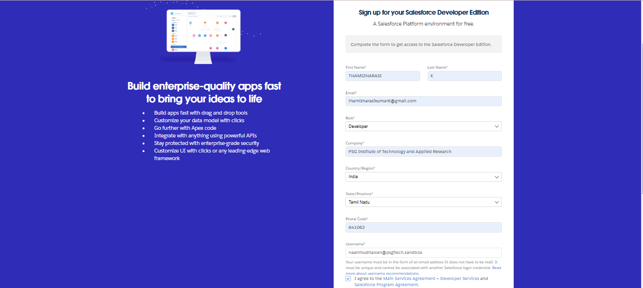

### **Account Activation**

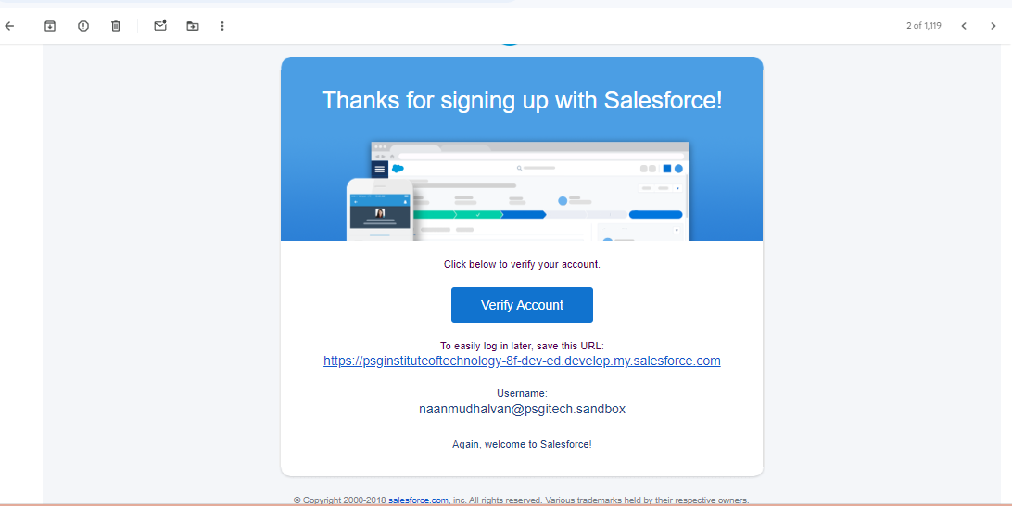

**Remark (by mentor):**

**Task no: 02**

**Task Name:Object**

**Done by:Thamizharasi K  
Screenshots:**

**Create Automobile Information Object**

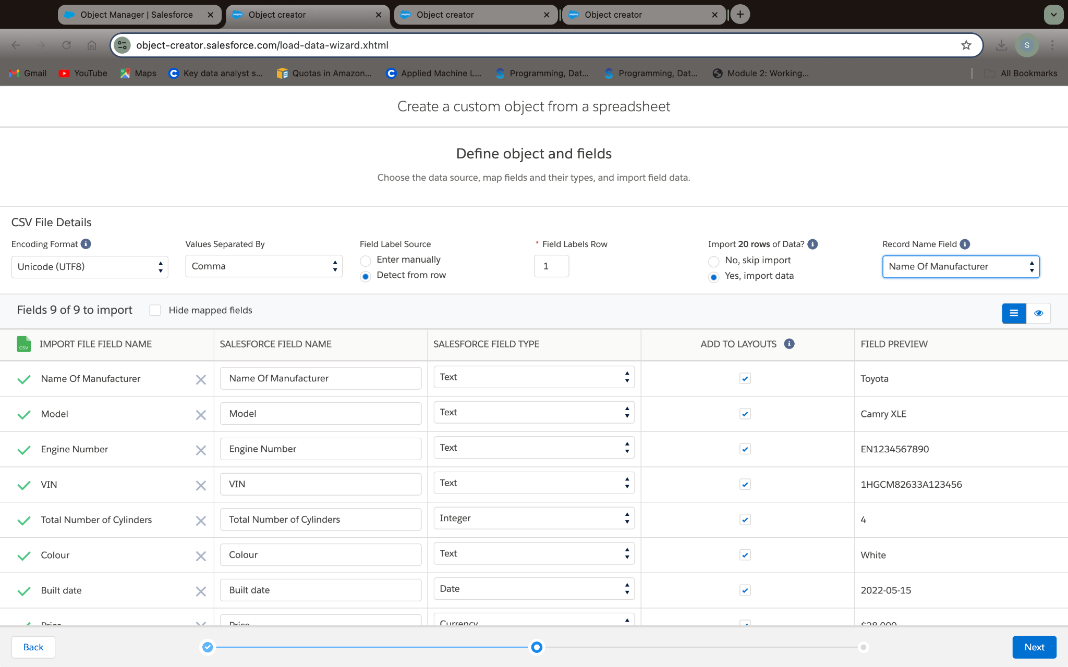

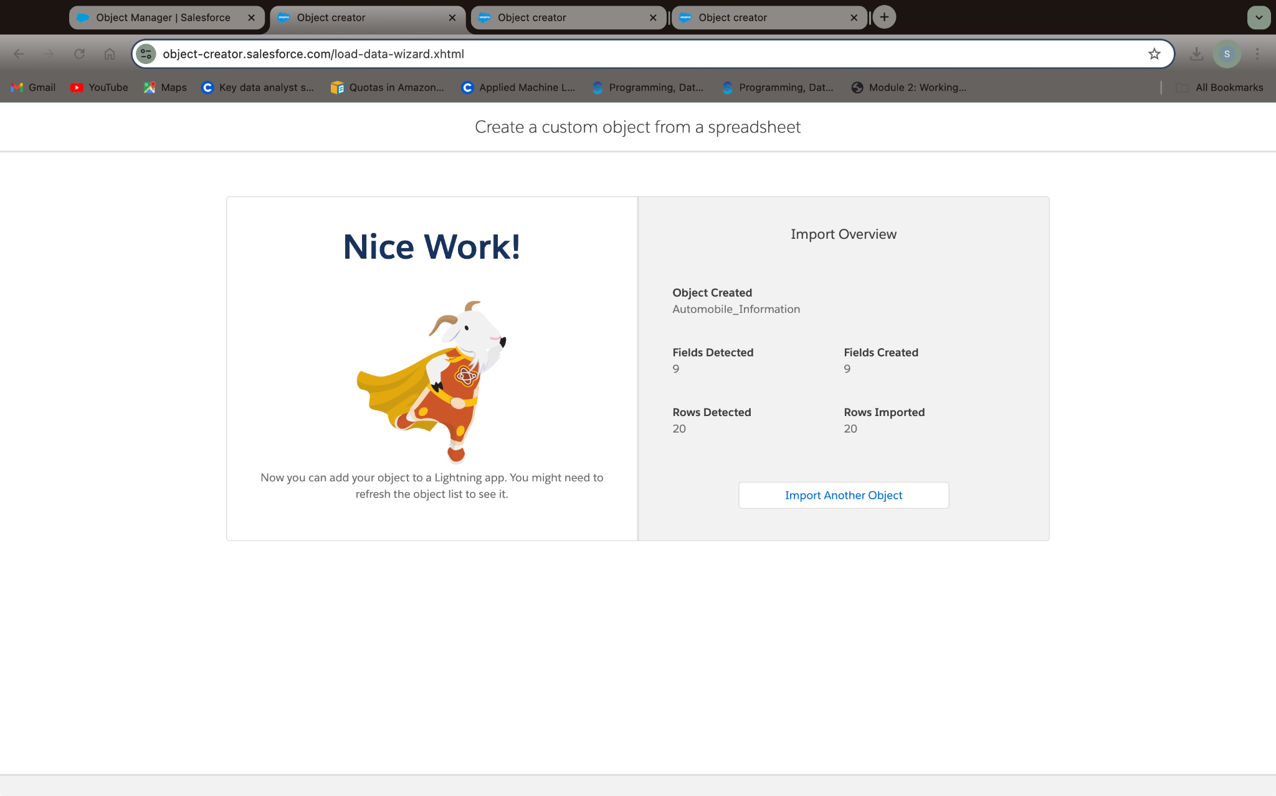

### **Create Invoice Object**

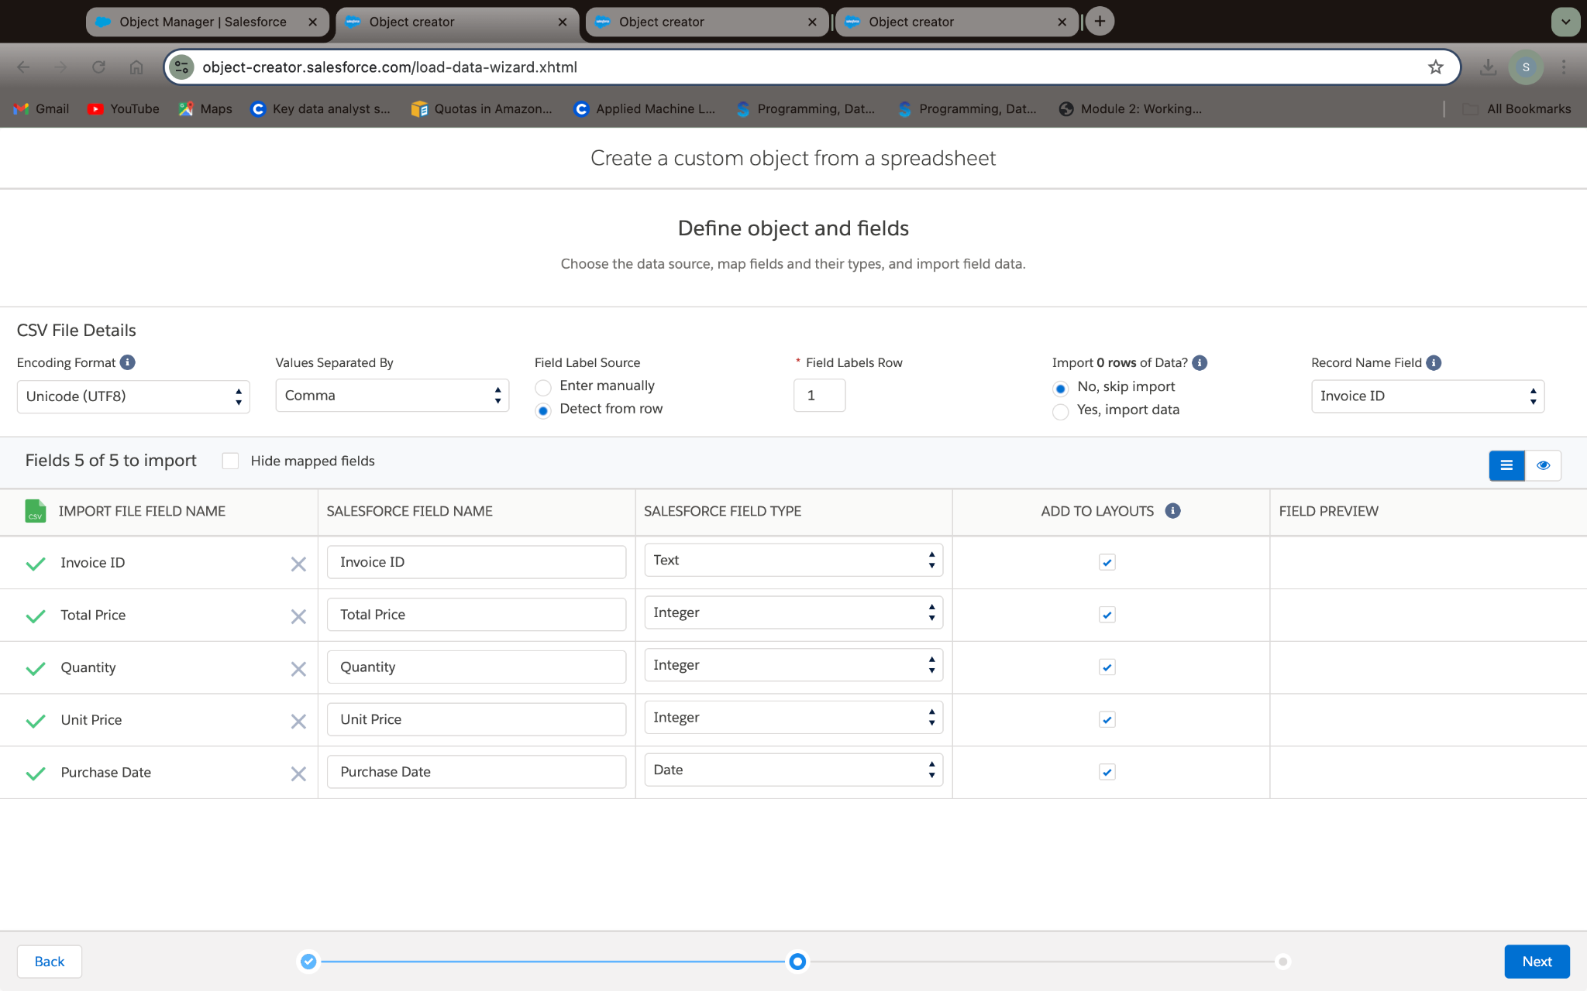

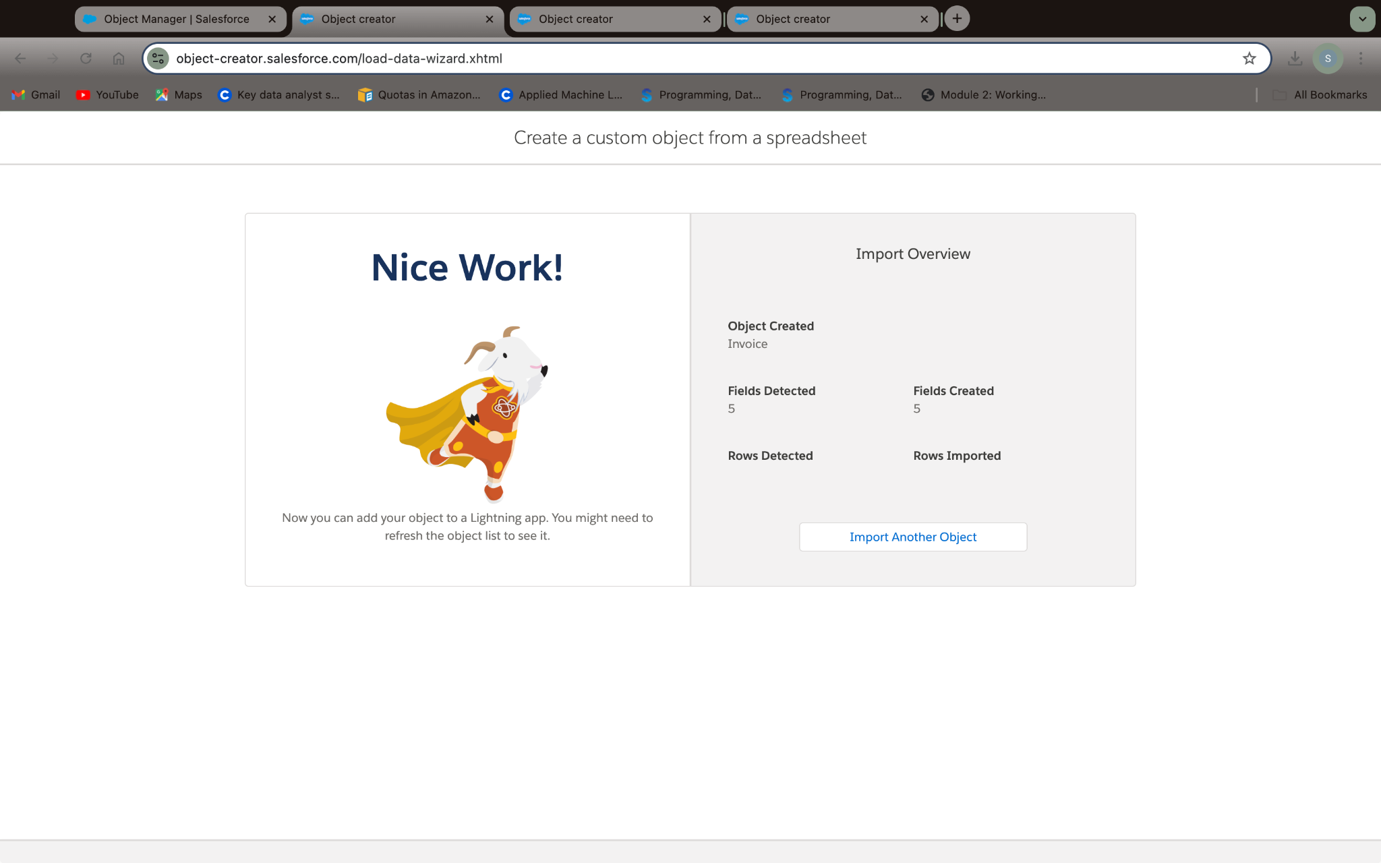

### **Create Automobile Object**

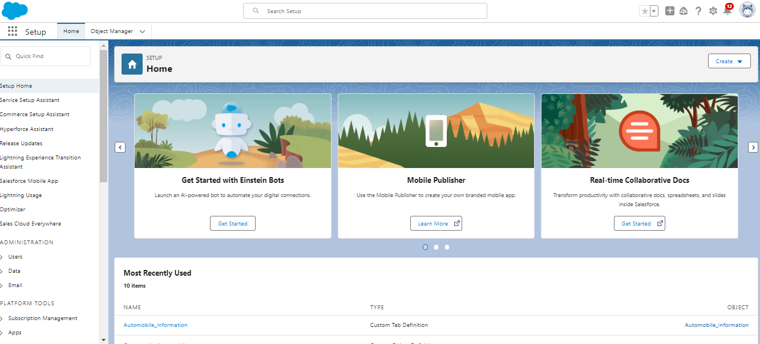

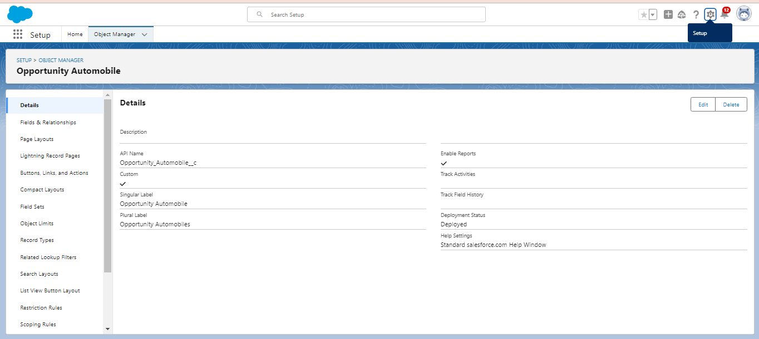

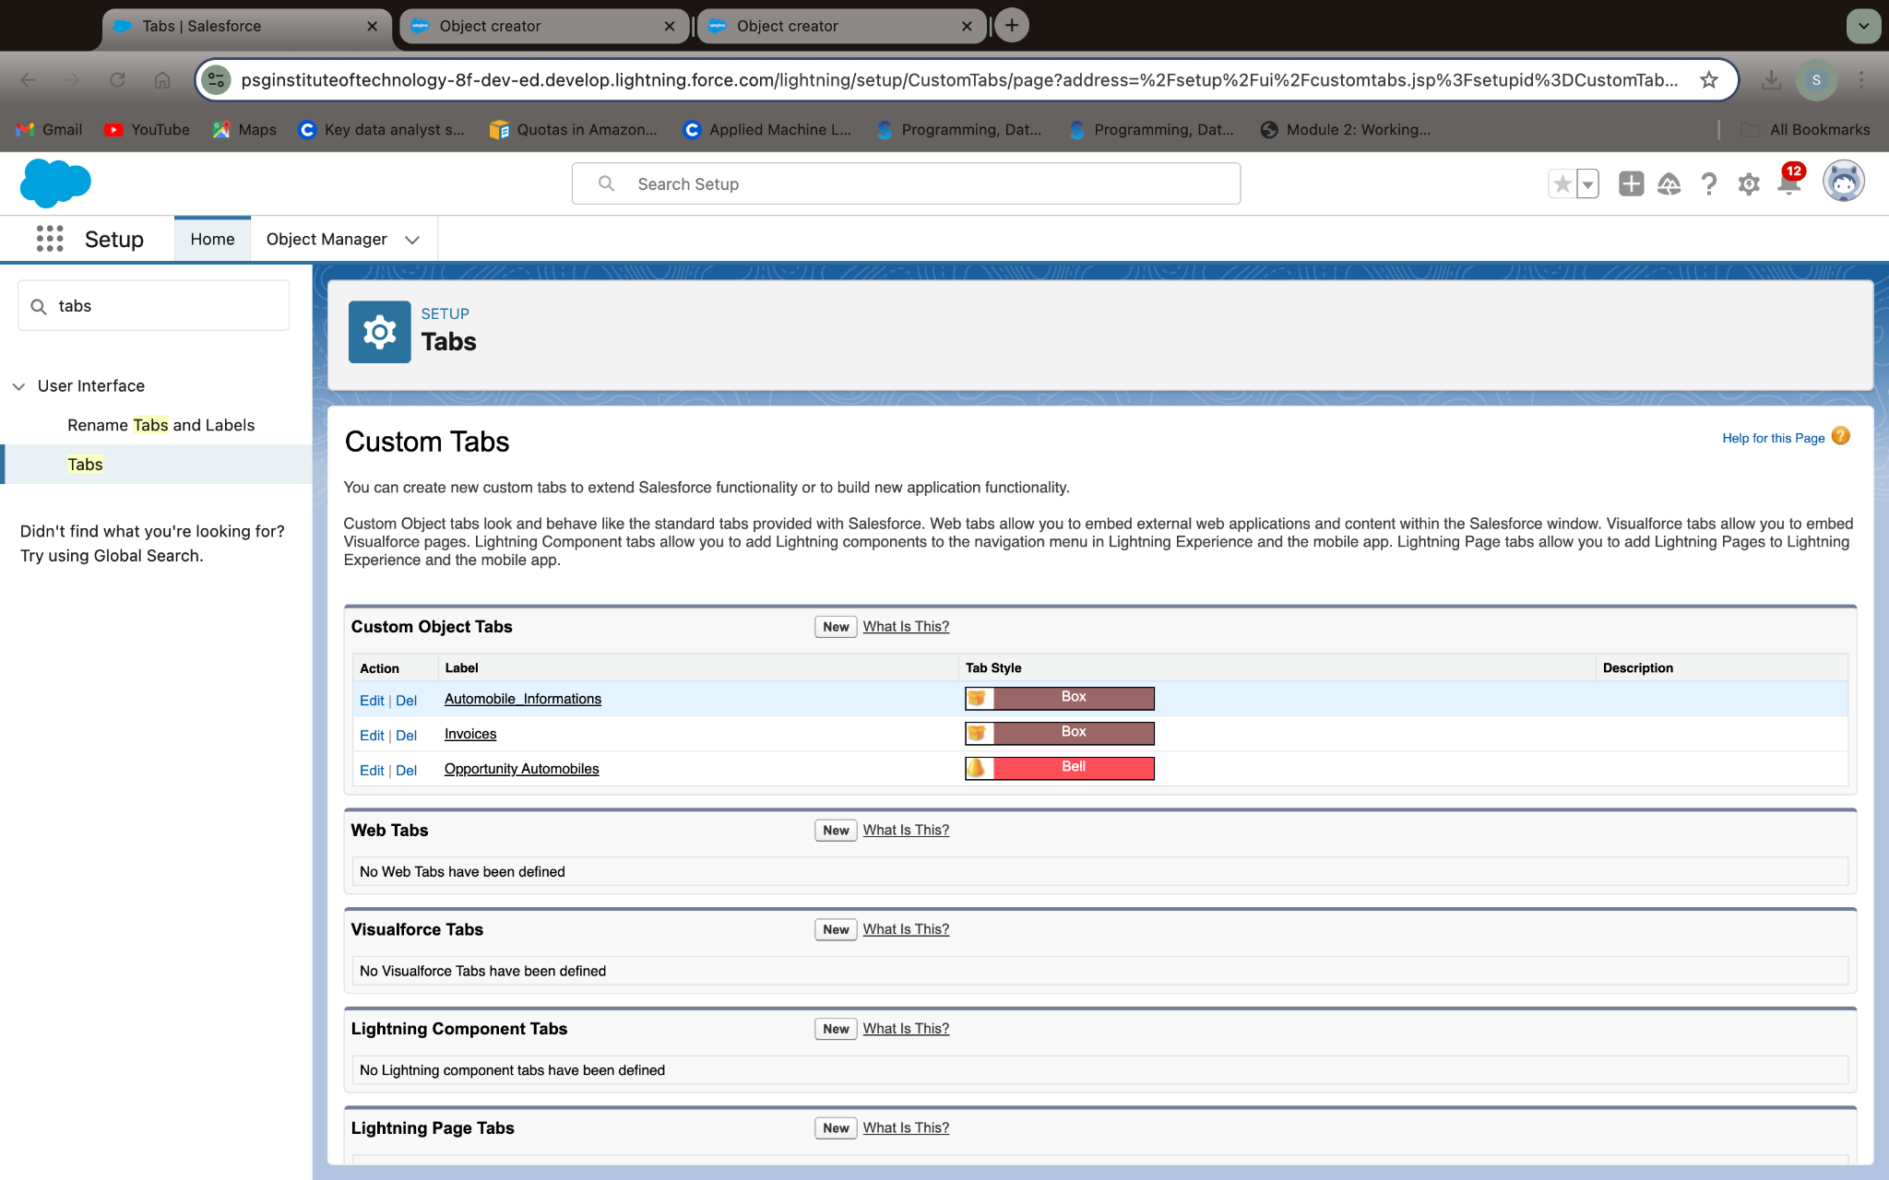

**Remark (by mentor):**

**Task no: 03**

**Task Name:Tab**

**Done by:Thamizharasi K  
Screenshots:**

**Creating a Custom Tab**

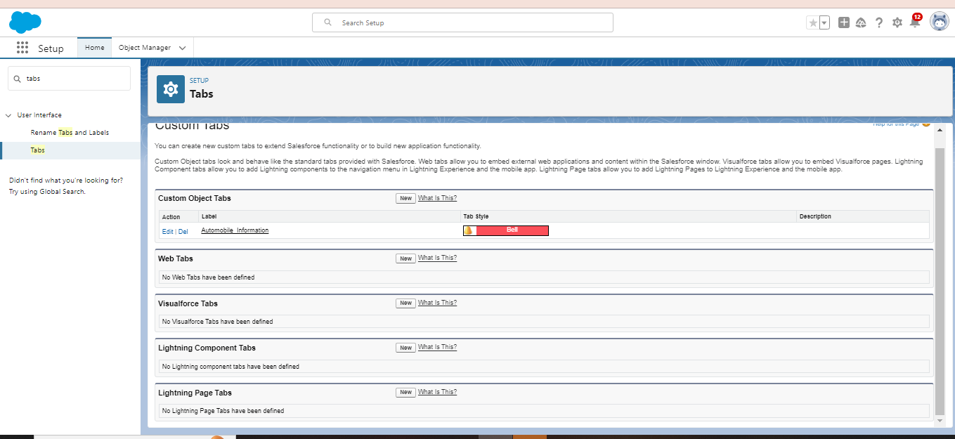

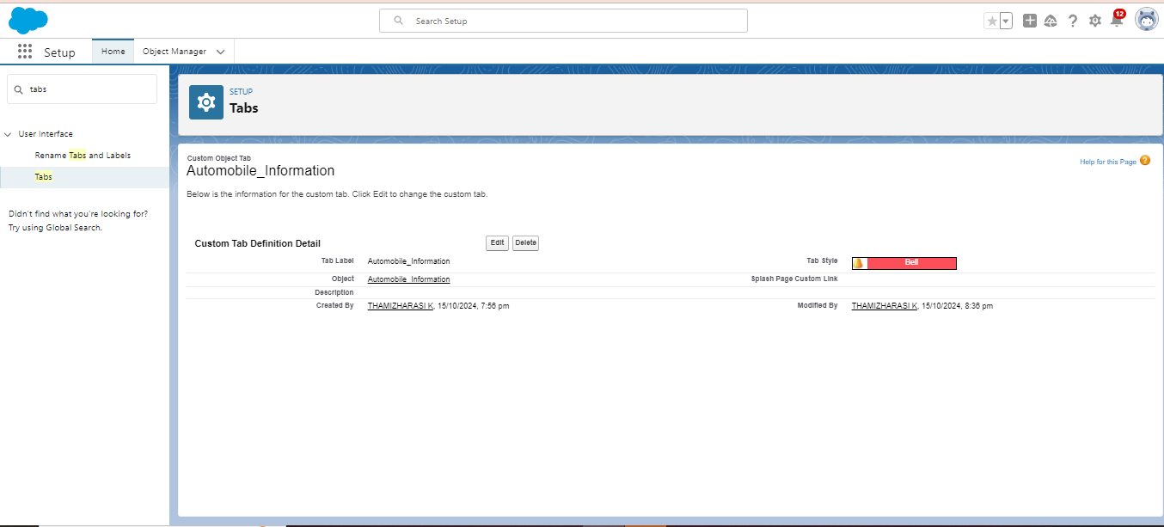

**Task no: 04**

**Task Name:The Lightning App**

**Done by:Sankari R K  
Screenshots:**

### **Create a Lightning App**

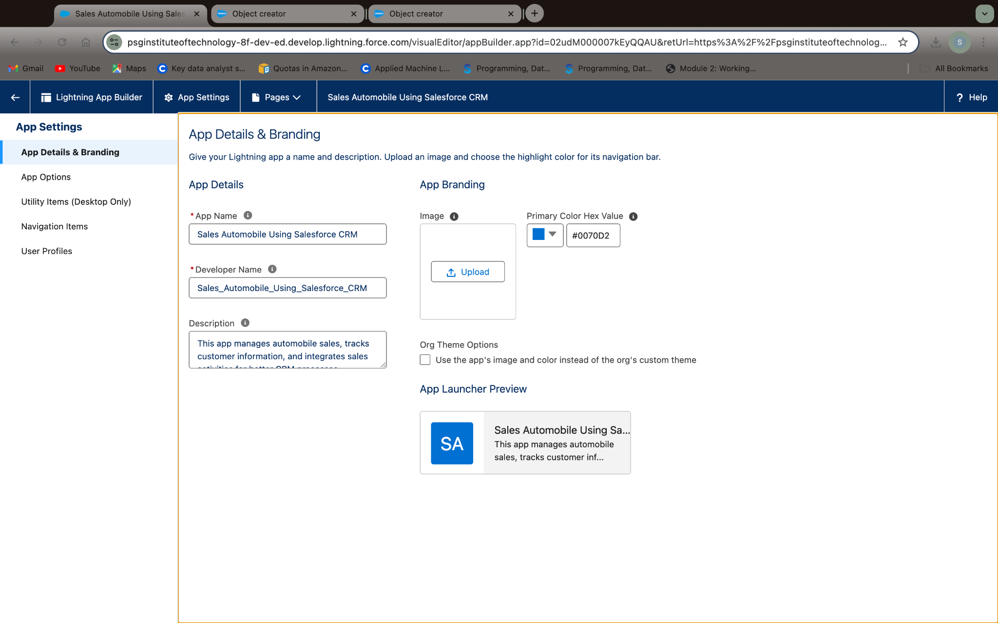

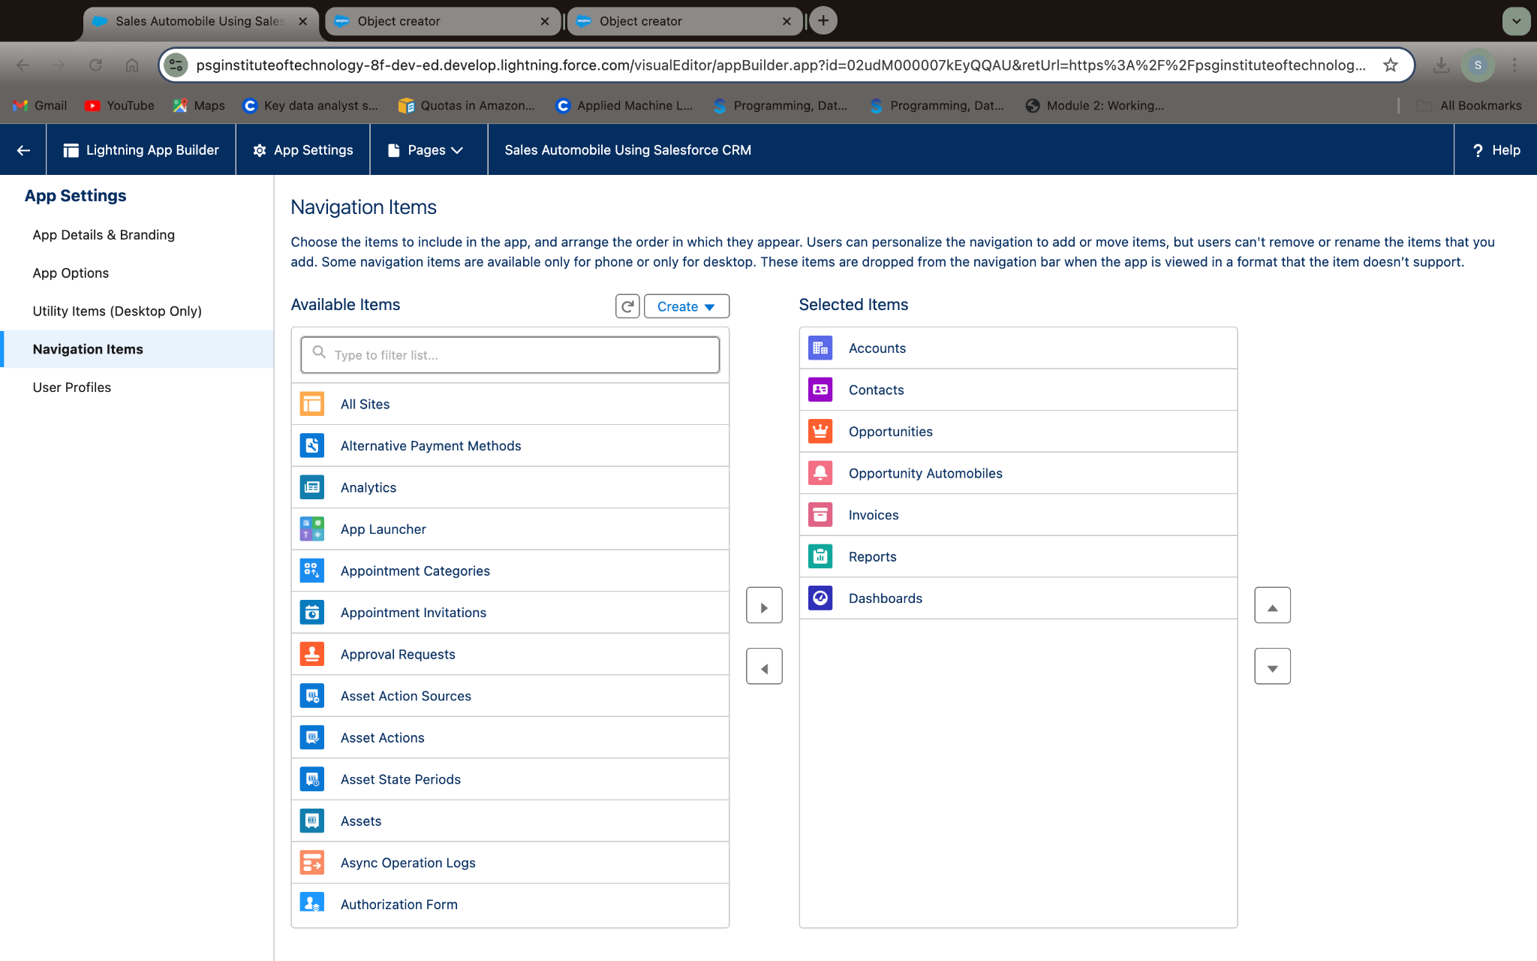

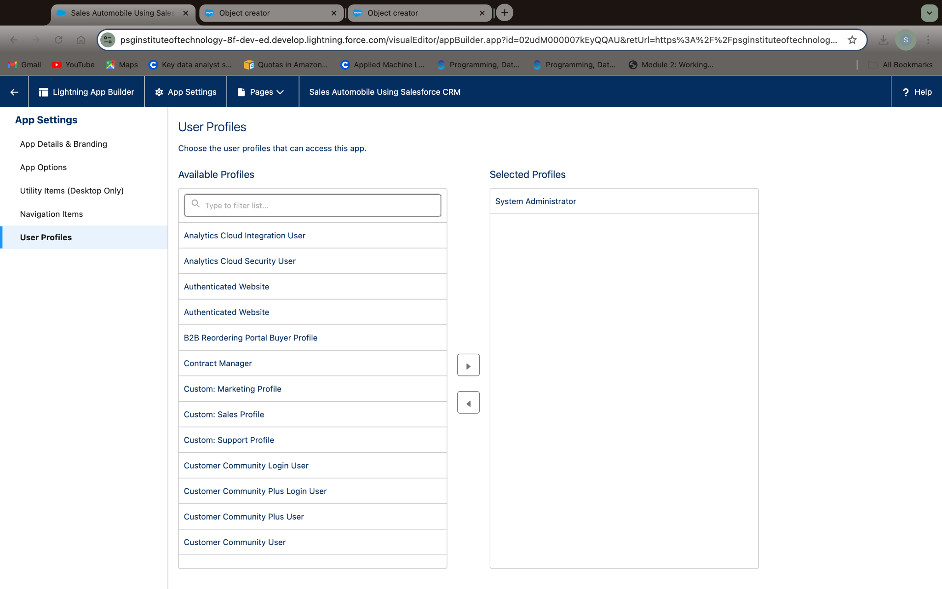

**Remark (by mentor):**

**Task no: 05**

**Task Name:Fields & Relationships**

**Done by:Sankari R K  
Screenshots:**

### **Creating Opportunity Master Detail Relationship Field in Opportunity AutoMobile Object**

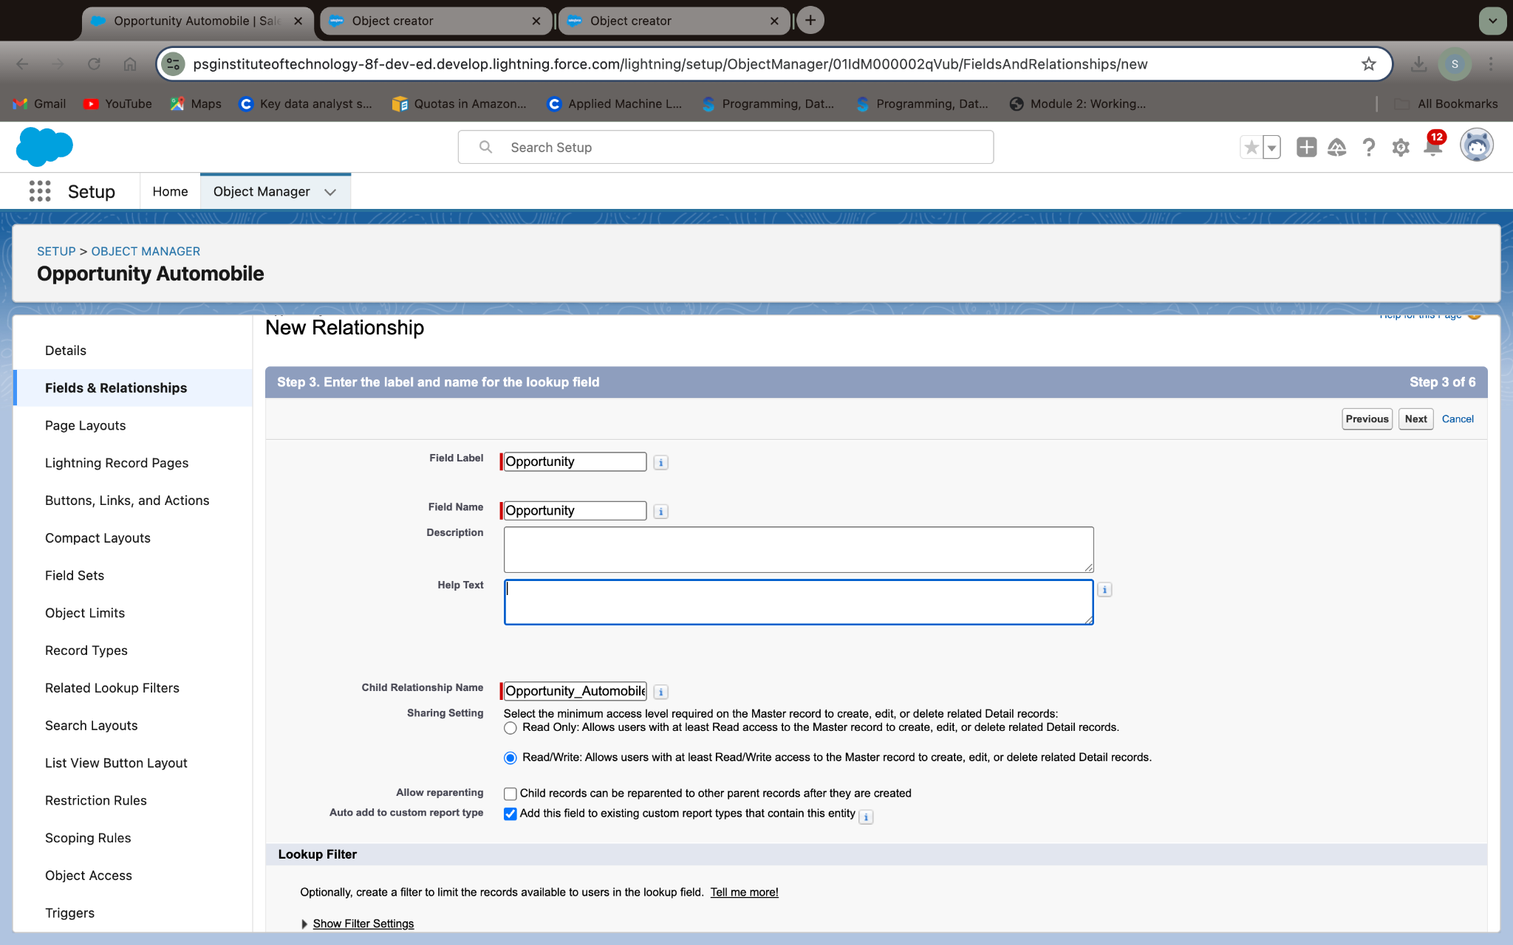

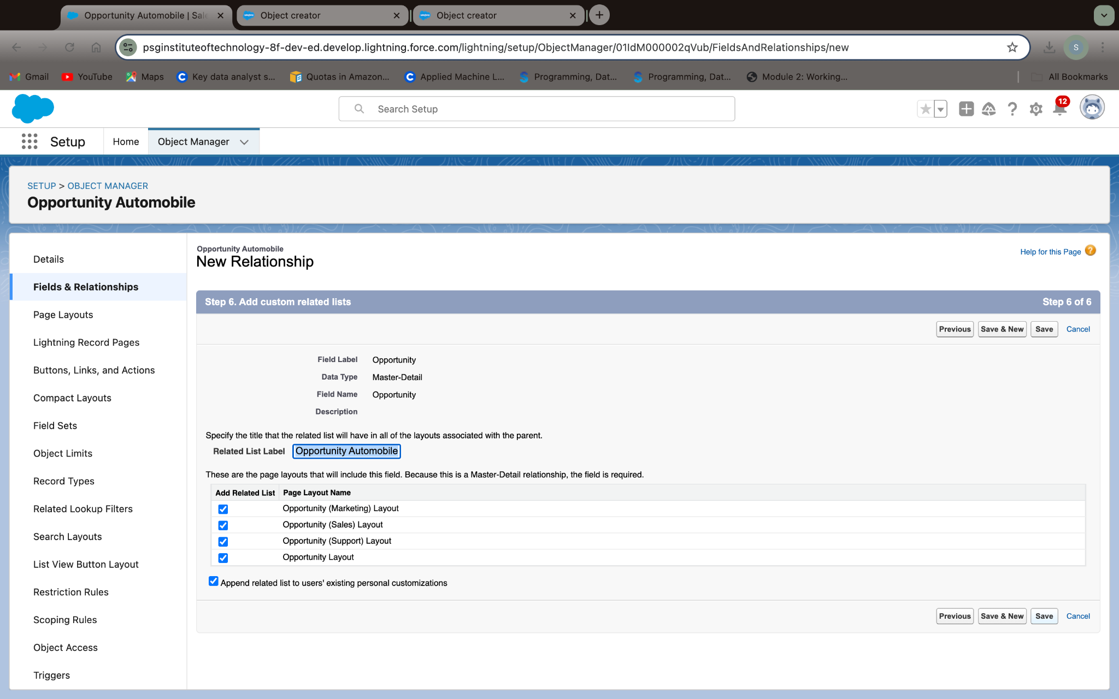

### 

### 

### 

### 

### 

**Remark (by mentor):**

### 

### 

### **Creating the AutoMobile Information Lookup Field in Opportunity Automobile Object**

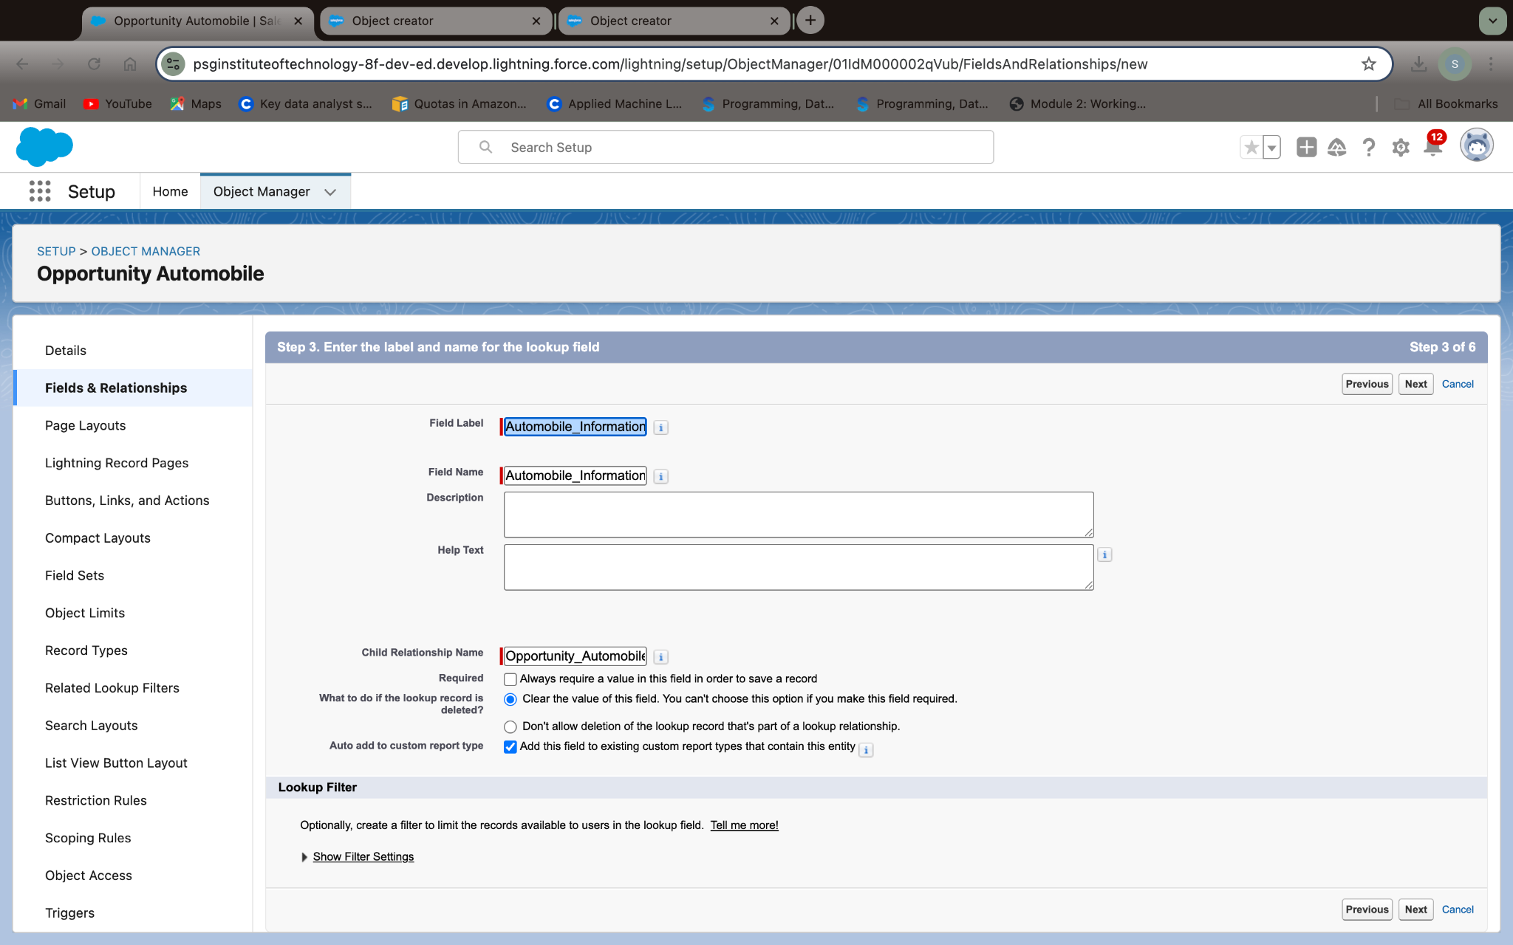

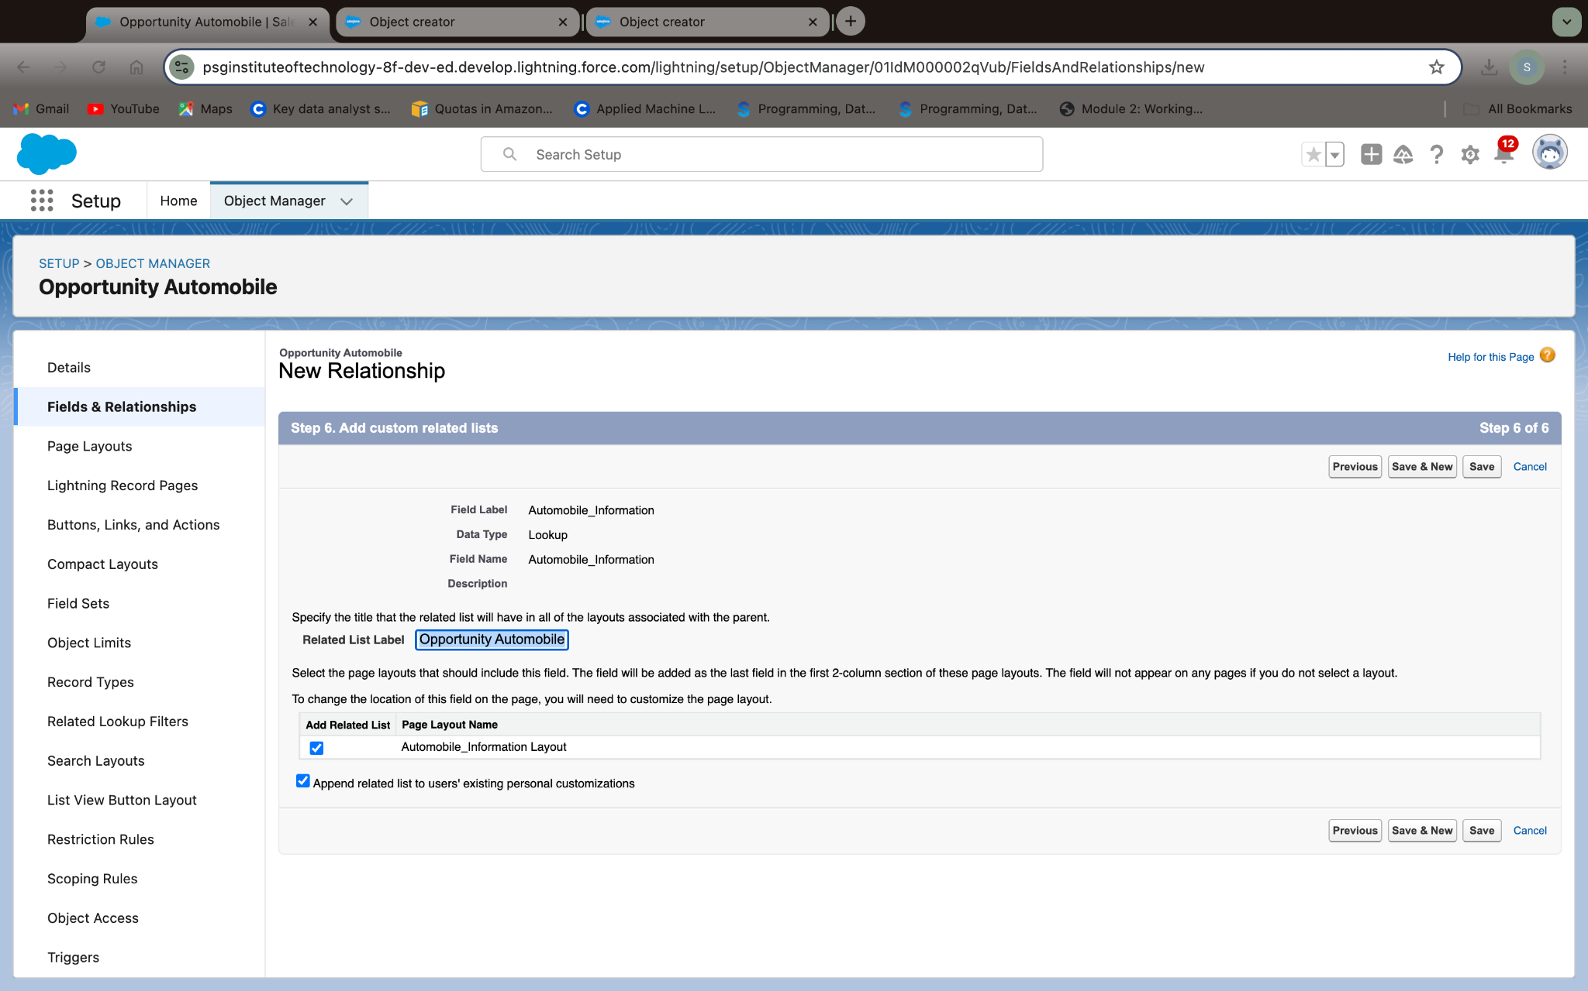

### **Creating Quantity Number Field in Opportunity Automobile Object**

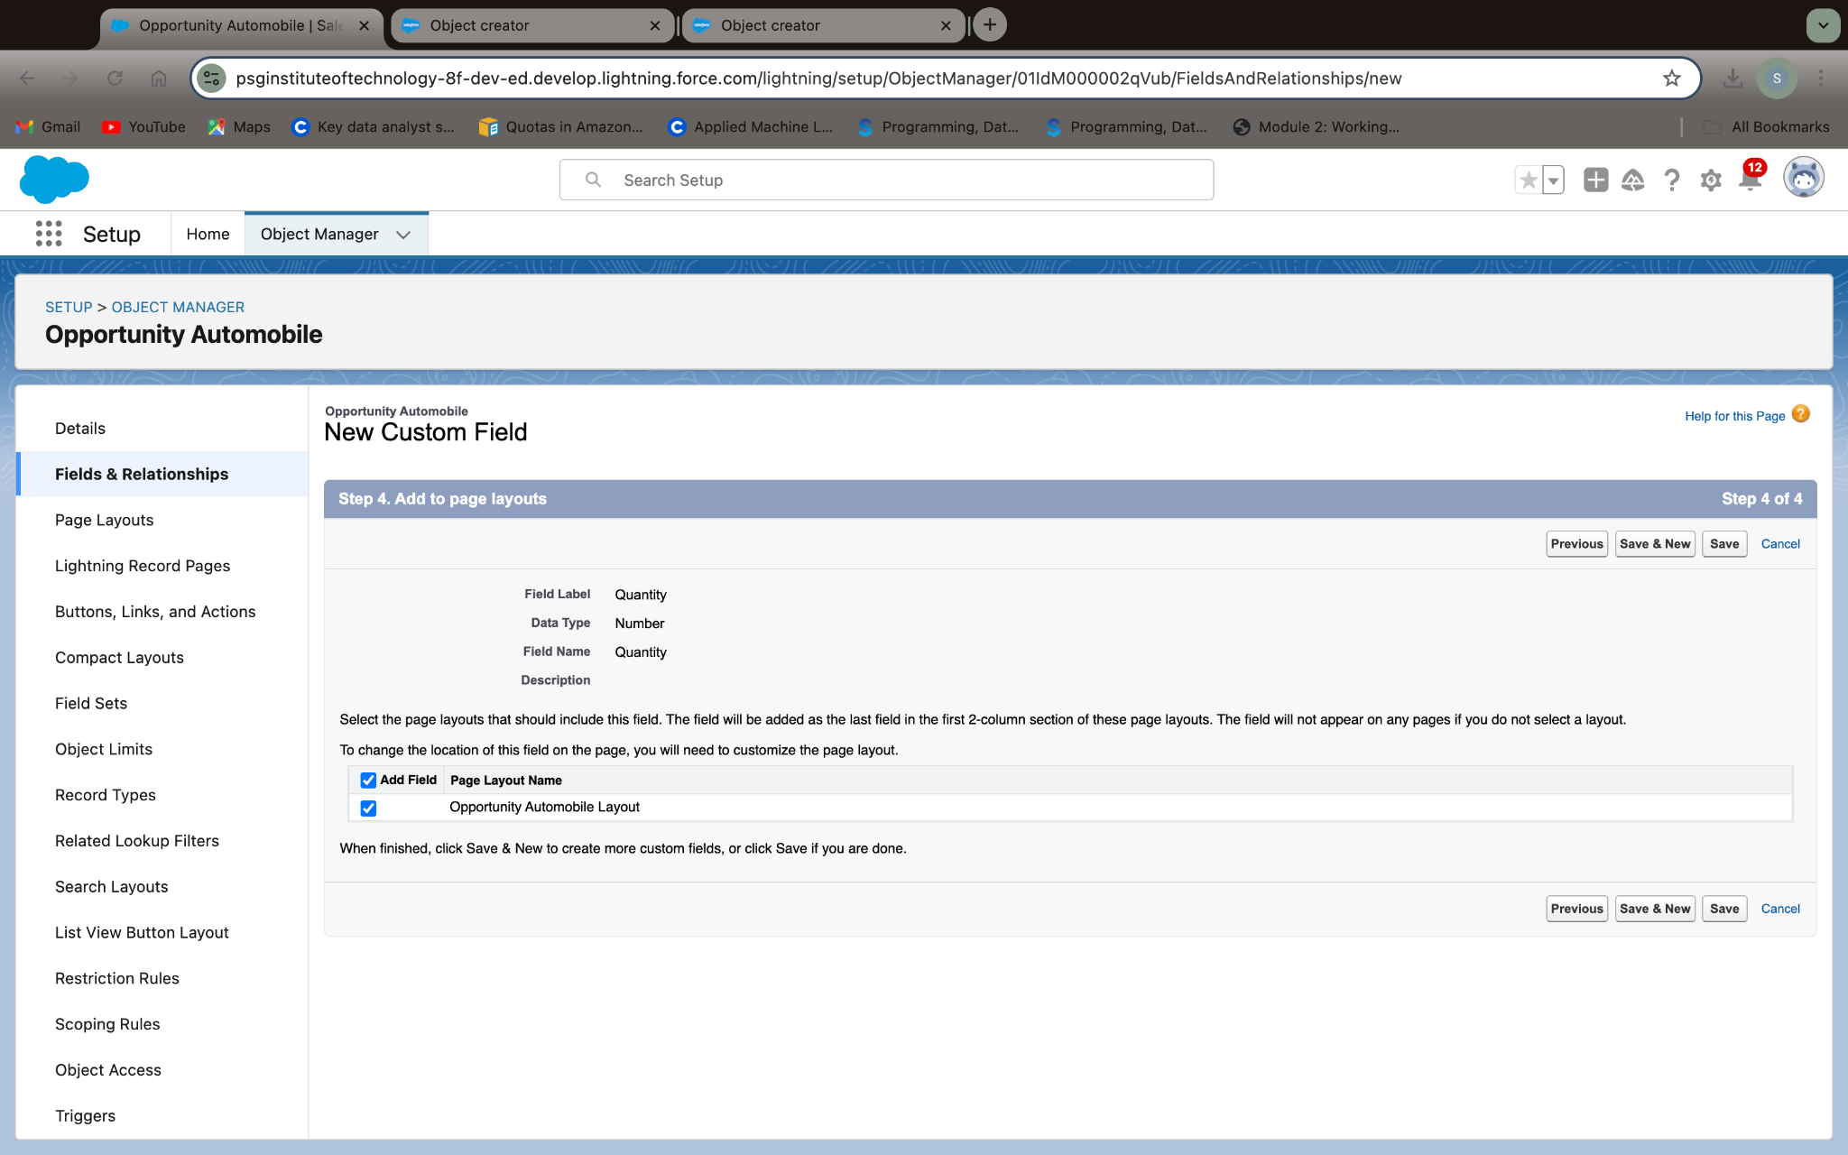

### 

### 

### 

### 

### 

### 

### 

### 

### **Creating Formula Field in Opportunity Automobile Object**

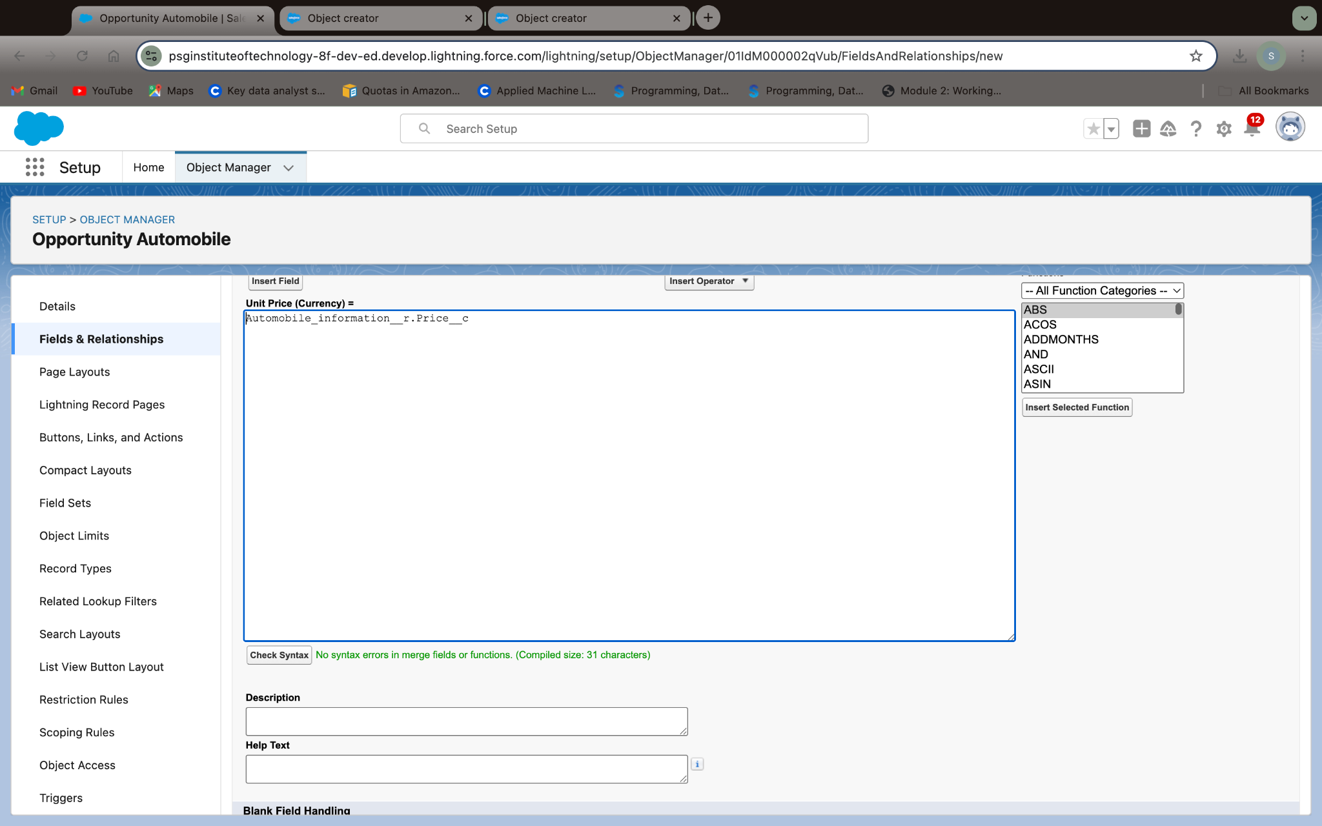

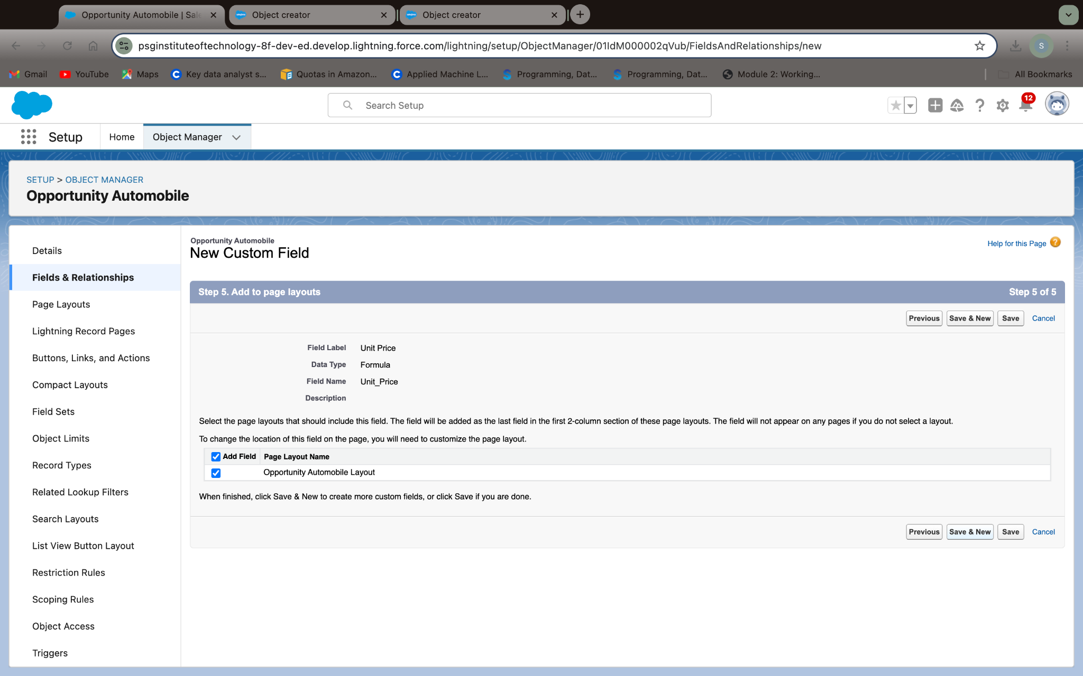

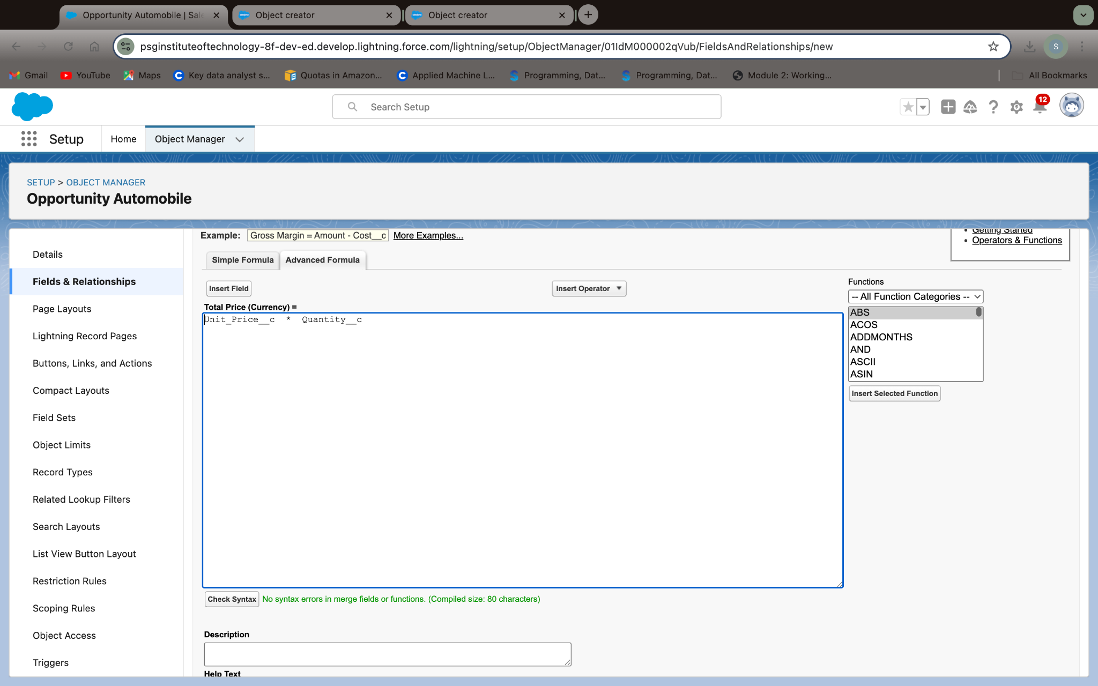

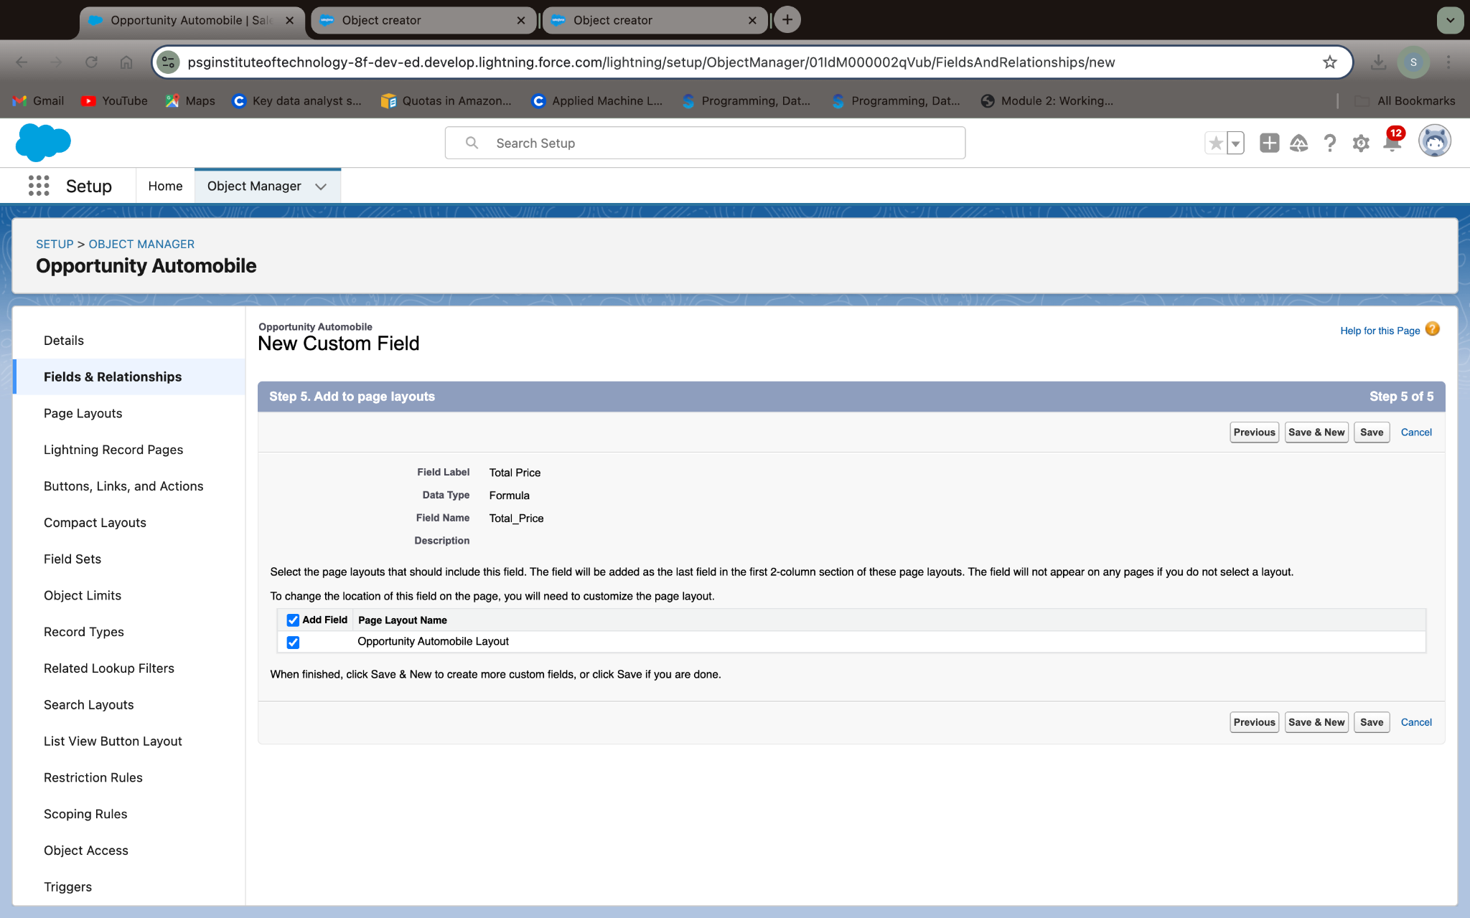

### **Updating field in Invoice Object**

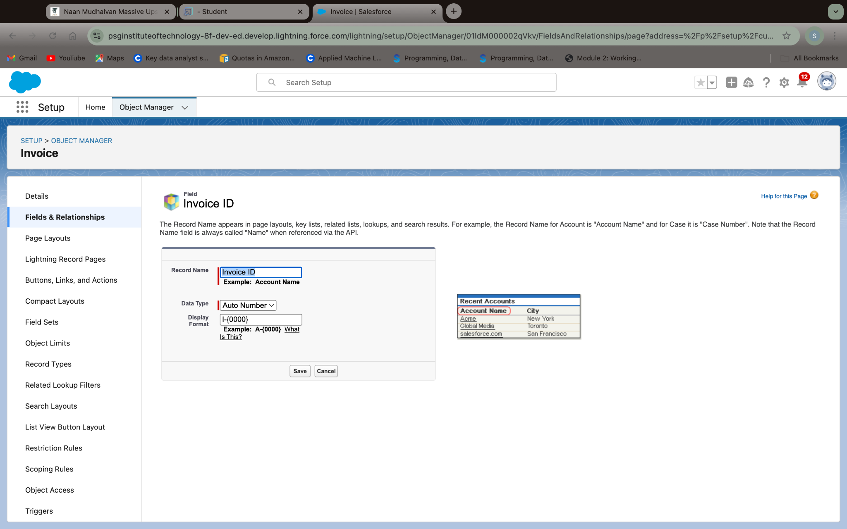

### 

### 

### 

### 

### 

### 

### 

### 

### **Creating Remaining Fields in Objects**

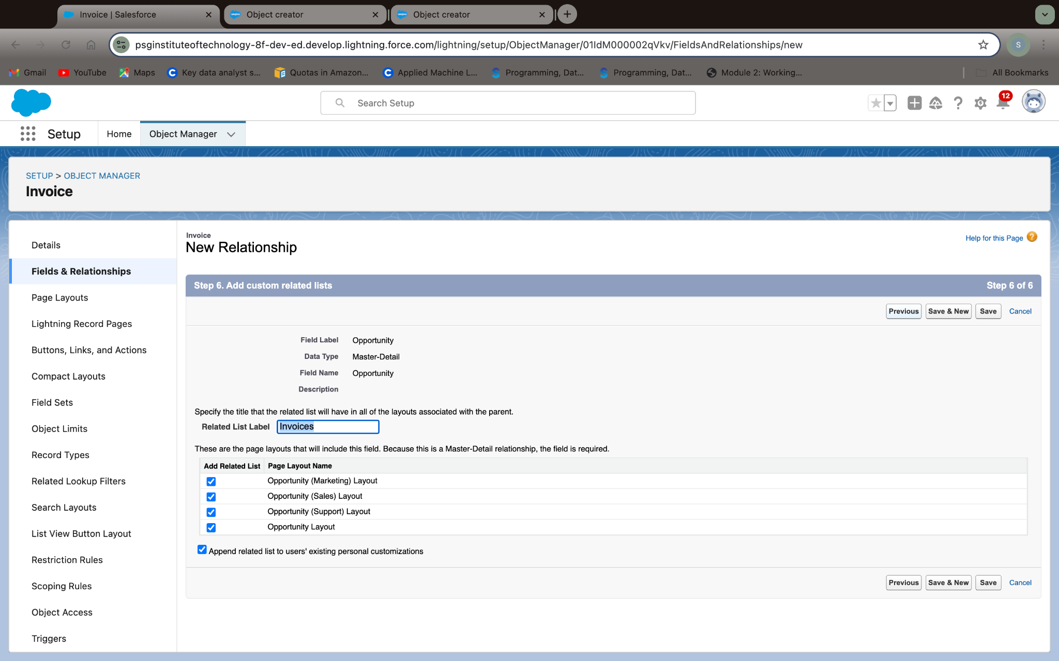

**Remark (by mentor):**

**Task no: 06**

**Task Name:Page Layouts**

**Done by:Ritanya T**

**Screenshots:**

**Layout for Opportunity Object:**

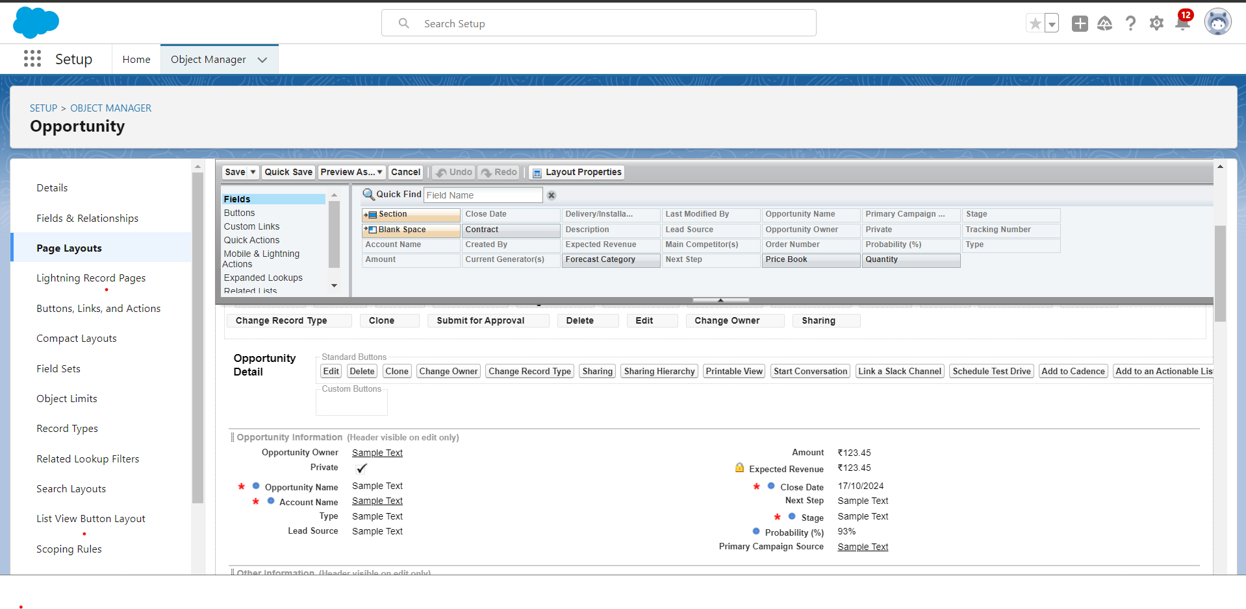

**Layout for Automobile Information**

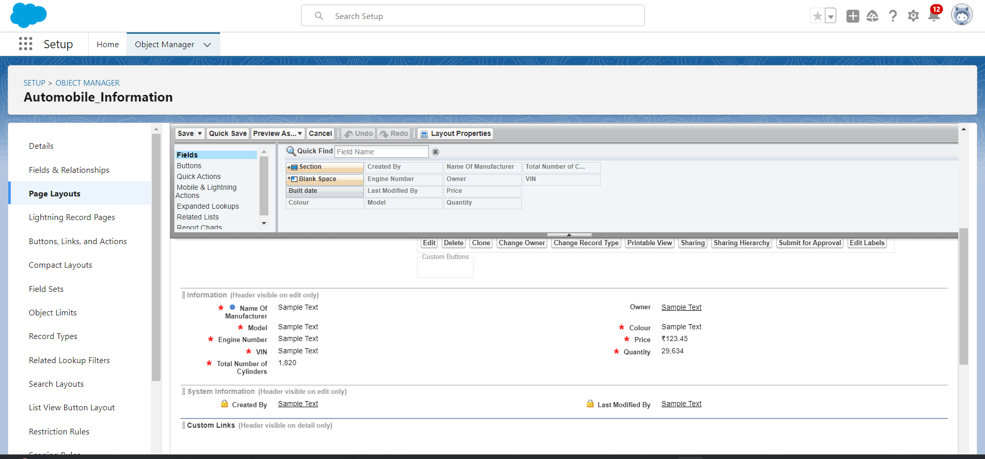

**Remark (by mentor):**

**Task no: 07**

**Task Name:Apex Triggers**

**Done by:Ritanya T**

**Screenshots:**

**Opportunity Handler**

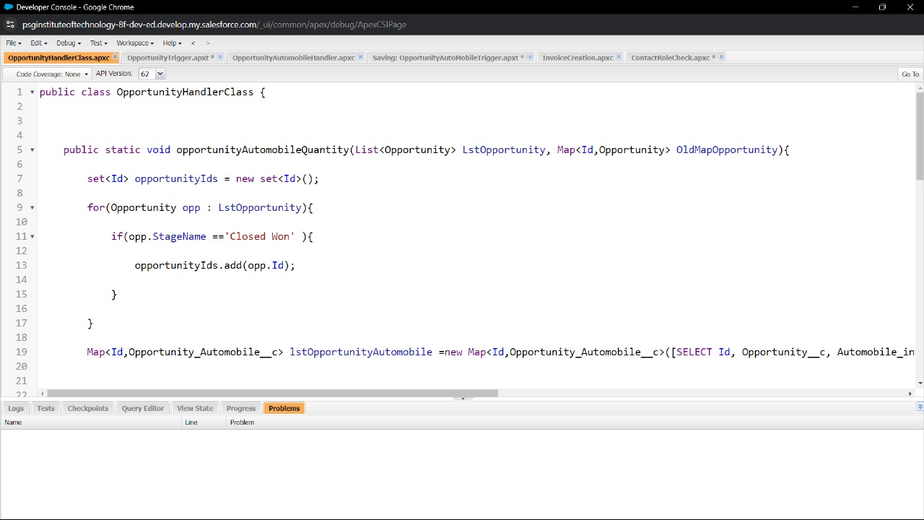

**Opportunity Trigger**

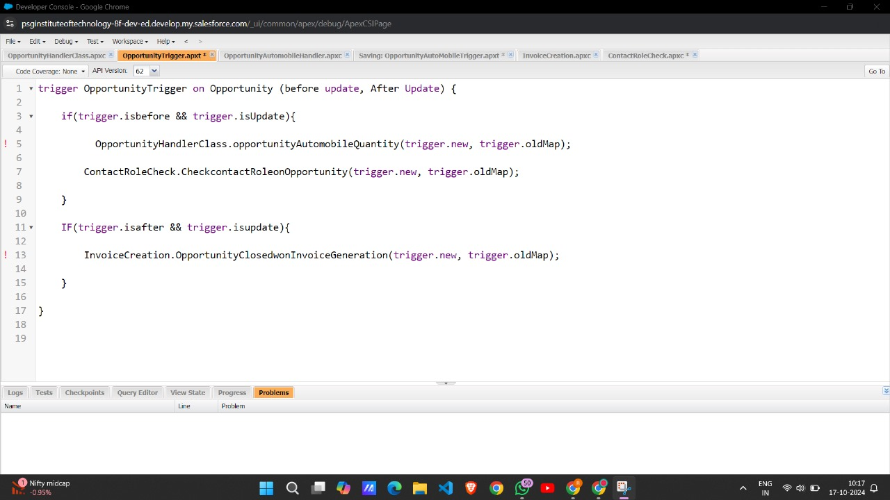

**Opportunity AutoMobile Trigger**

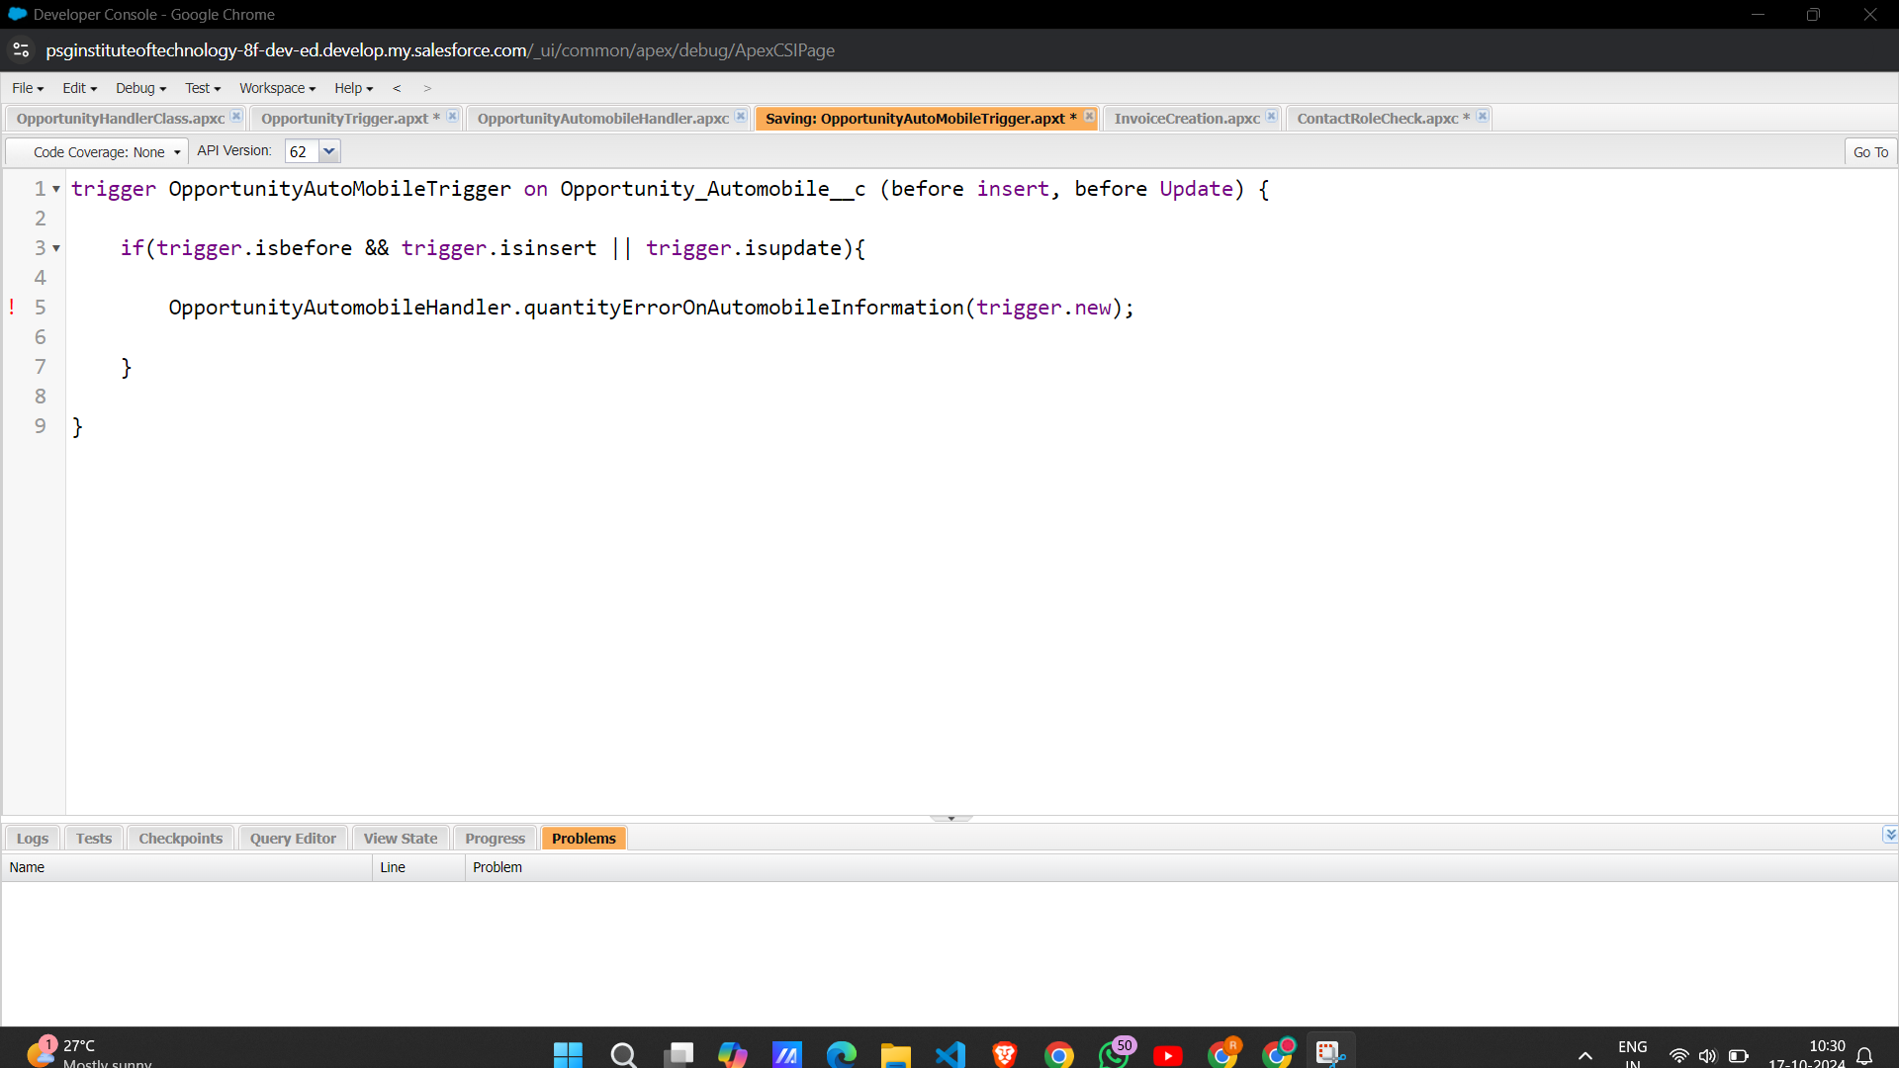

**Invoice Creation**

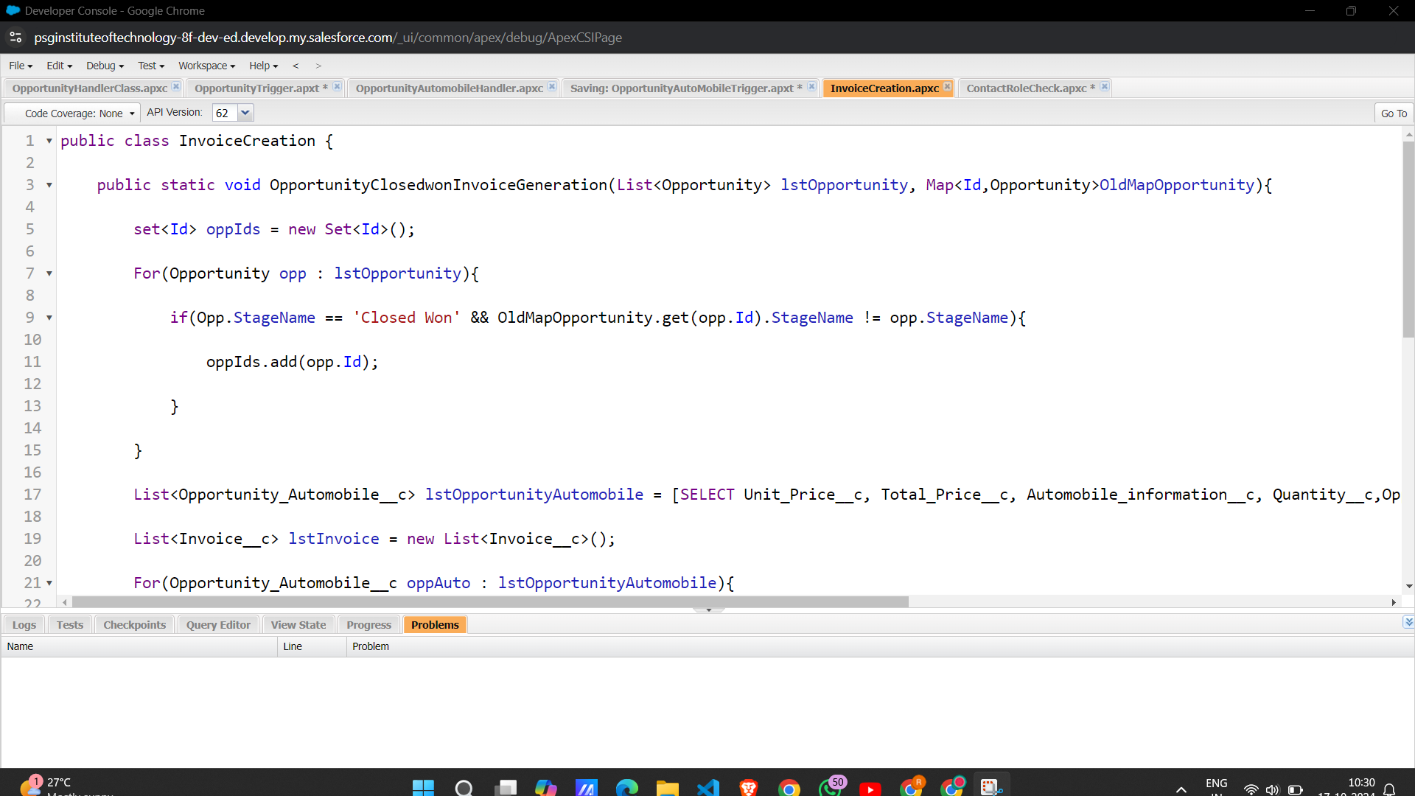

**Contact Role Check**

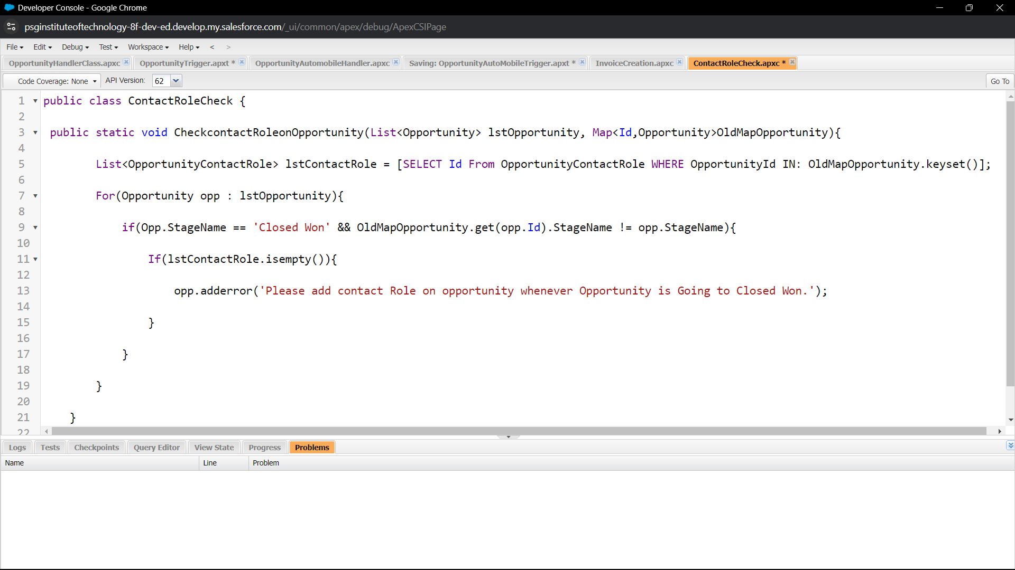

**Remark (by mentor):**

**Task no: 08**

**Task Name:LWC Component**

**Done by:Sreethigaa S  
Screenshots:**

**Create Apex Class to Get Invoices**

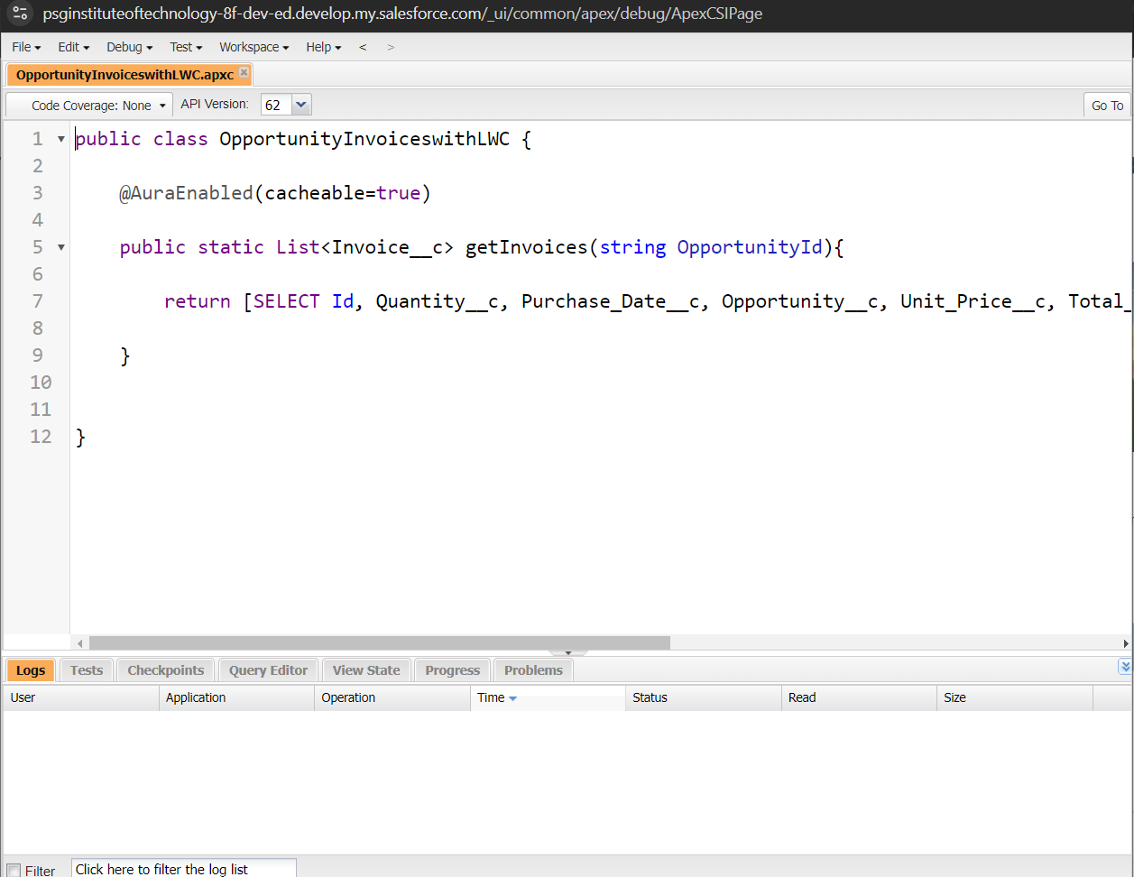

**Install Salesforce CLI**

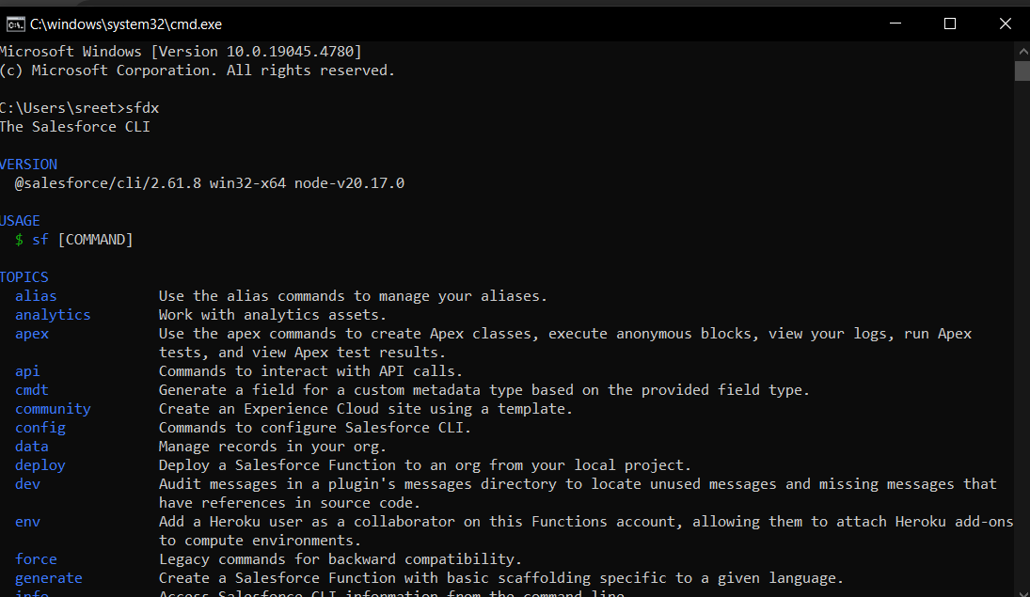

**Install Microsoft VS Code**

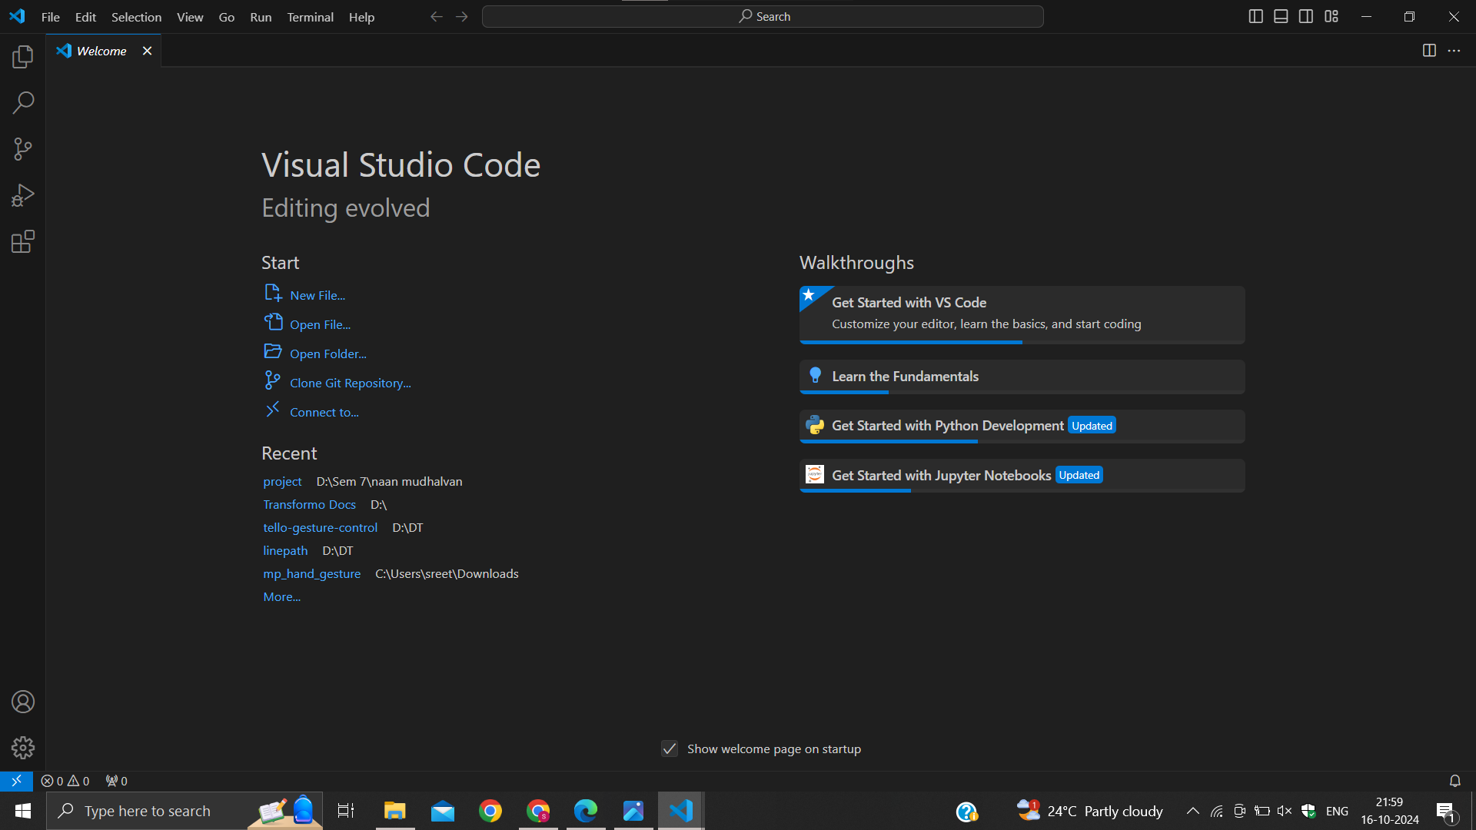

**Install the Salesforce Extension Pack**

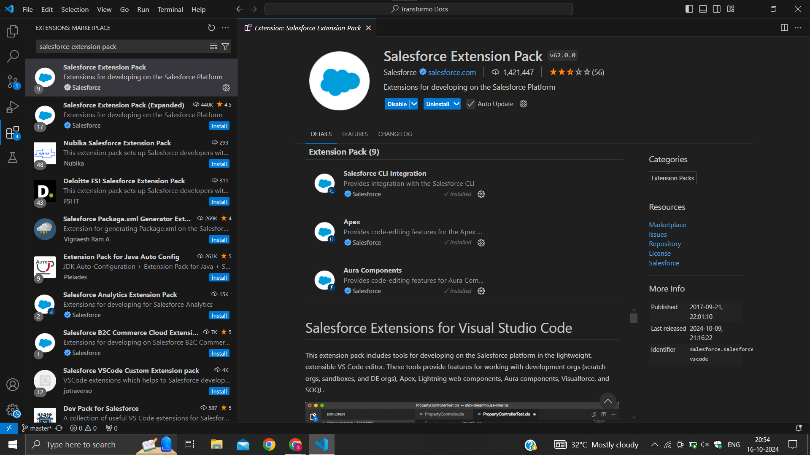

**Create a project in VS Code**

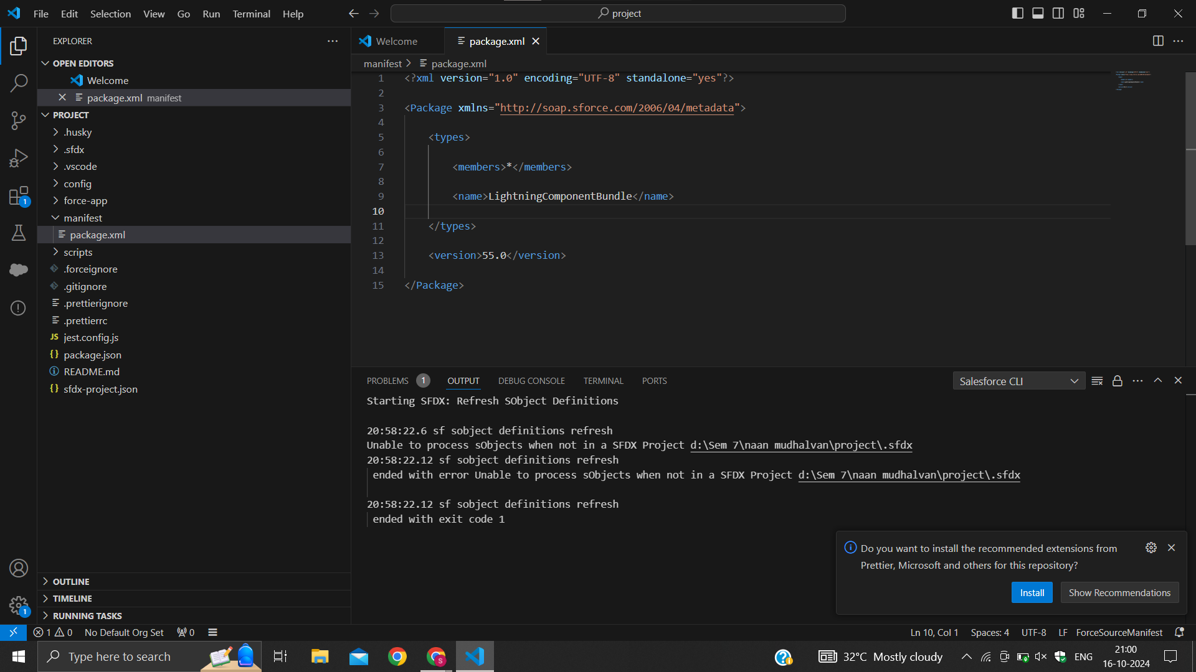

**Authorize an org**

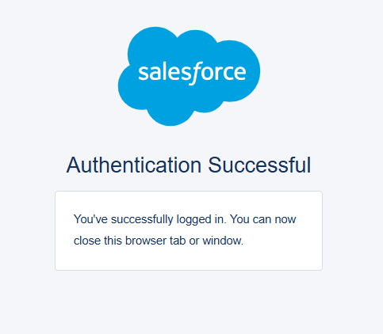

**Create Lightning Web Component**

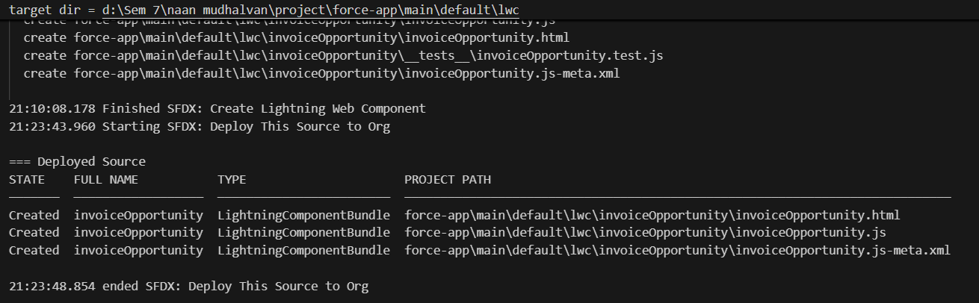

**Create Button to Add on Opportunity**

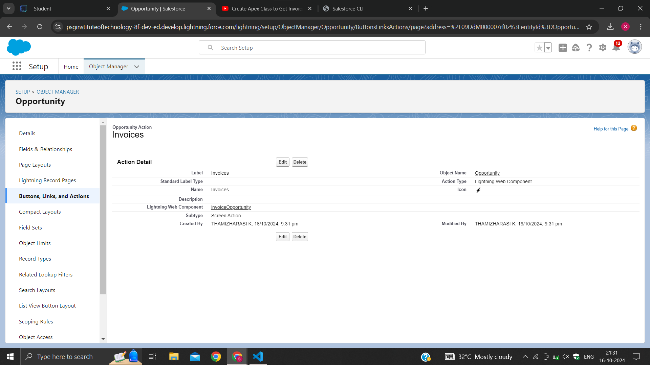

**Add InvoiceOpportunity into Opportunity Record Page**

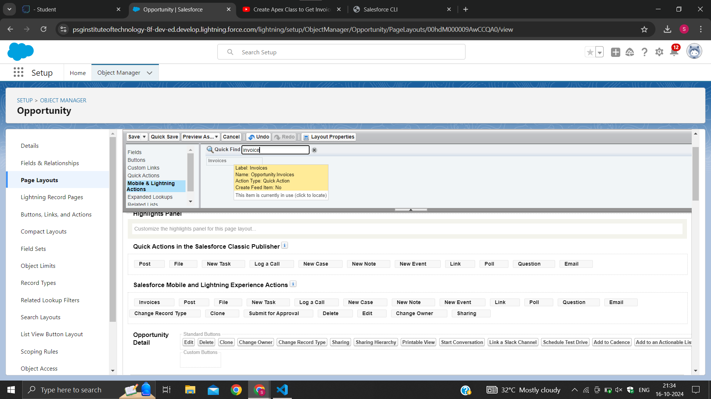

**Remark (by mentor):**

**Task no: 09**

**Task Name:Apex Schedulers**

**Done by:Sreethigaa S  
Screenshots:**

**Delete opportunity Schedule Class**

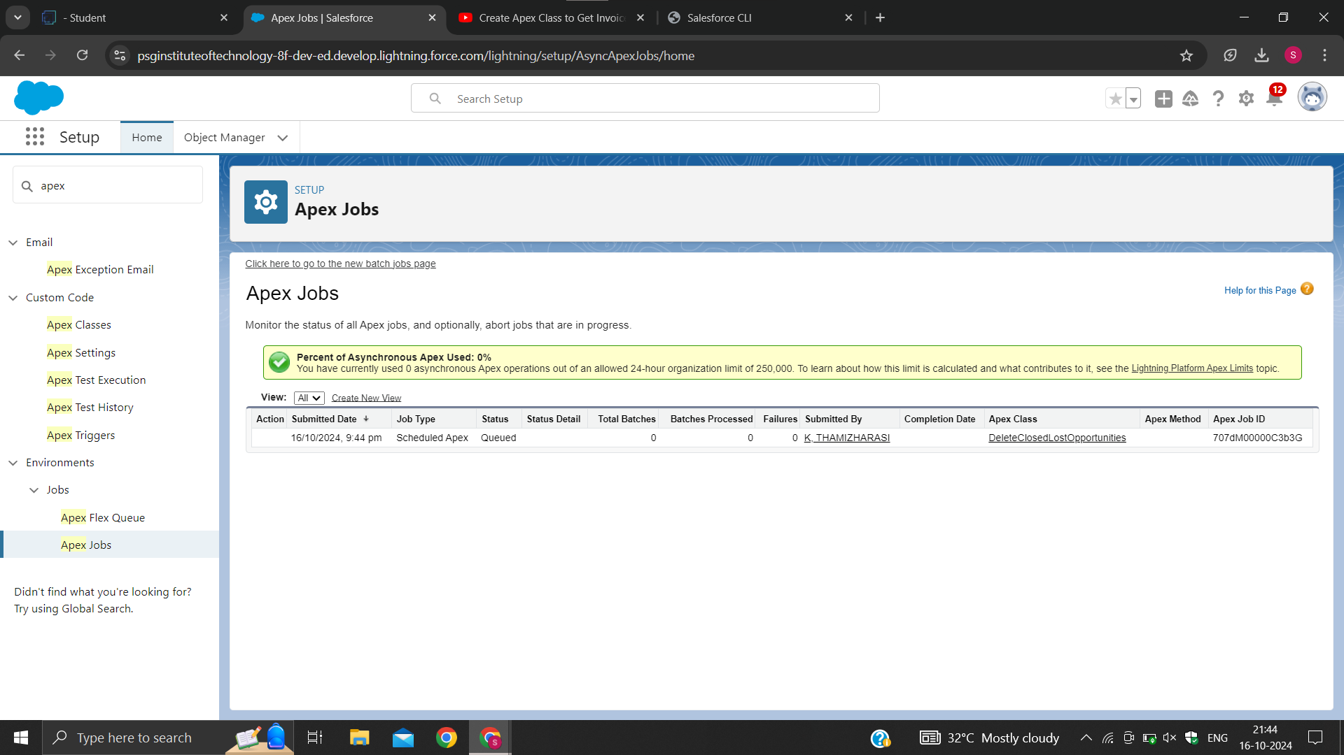

**Remark (by mentor):**

**Task no: 10**

**Task Name:Reports**

**Done by:Srinithi A  
Screenshots:**

### **Create Report on Opportunity**

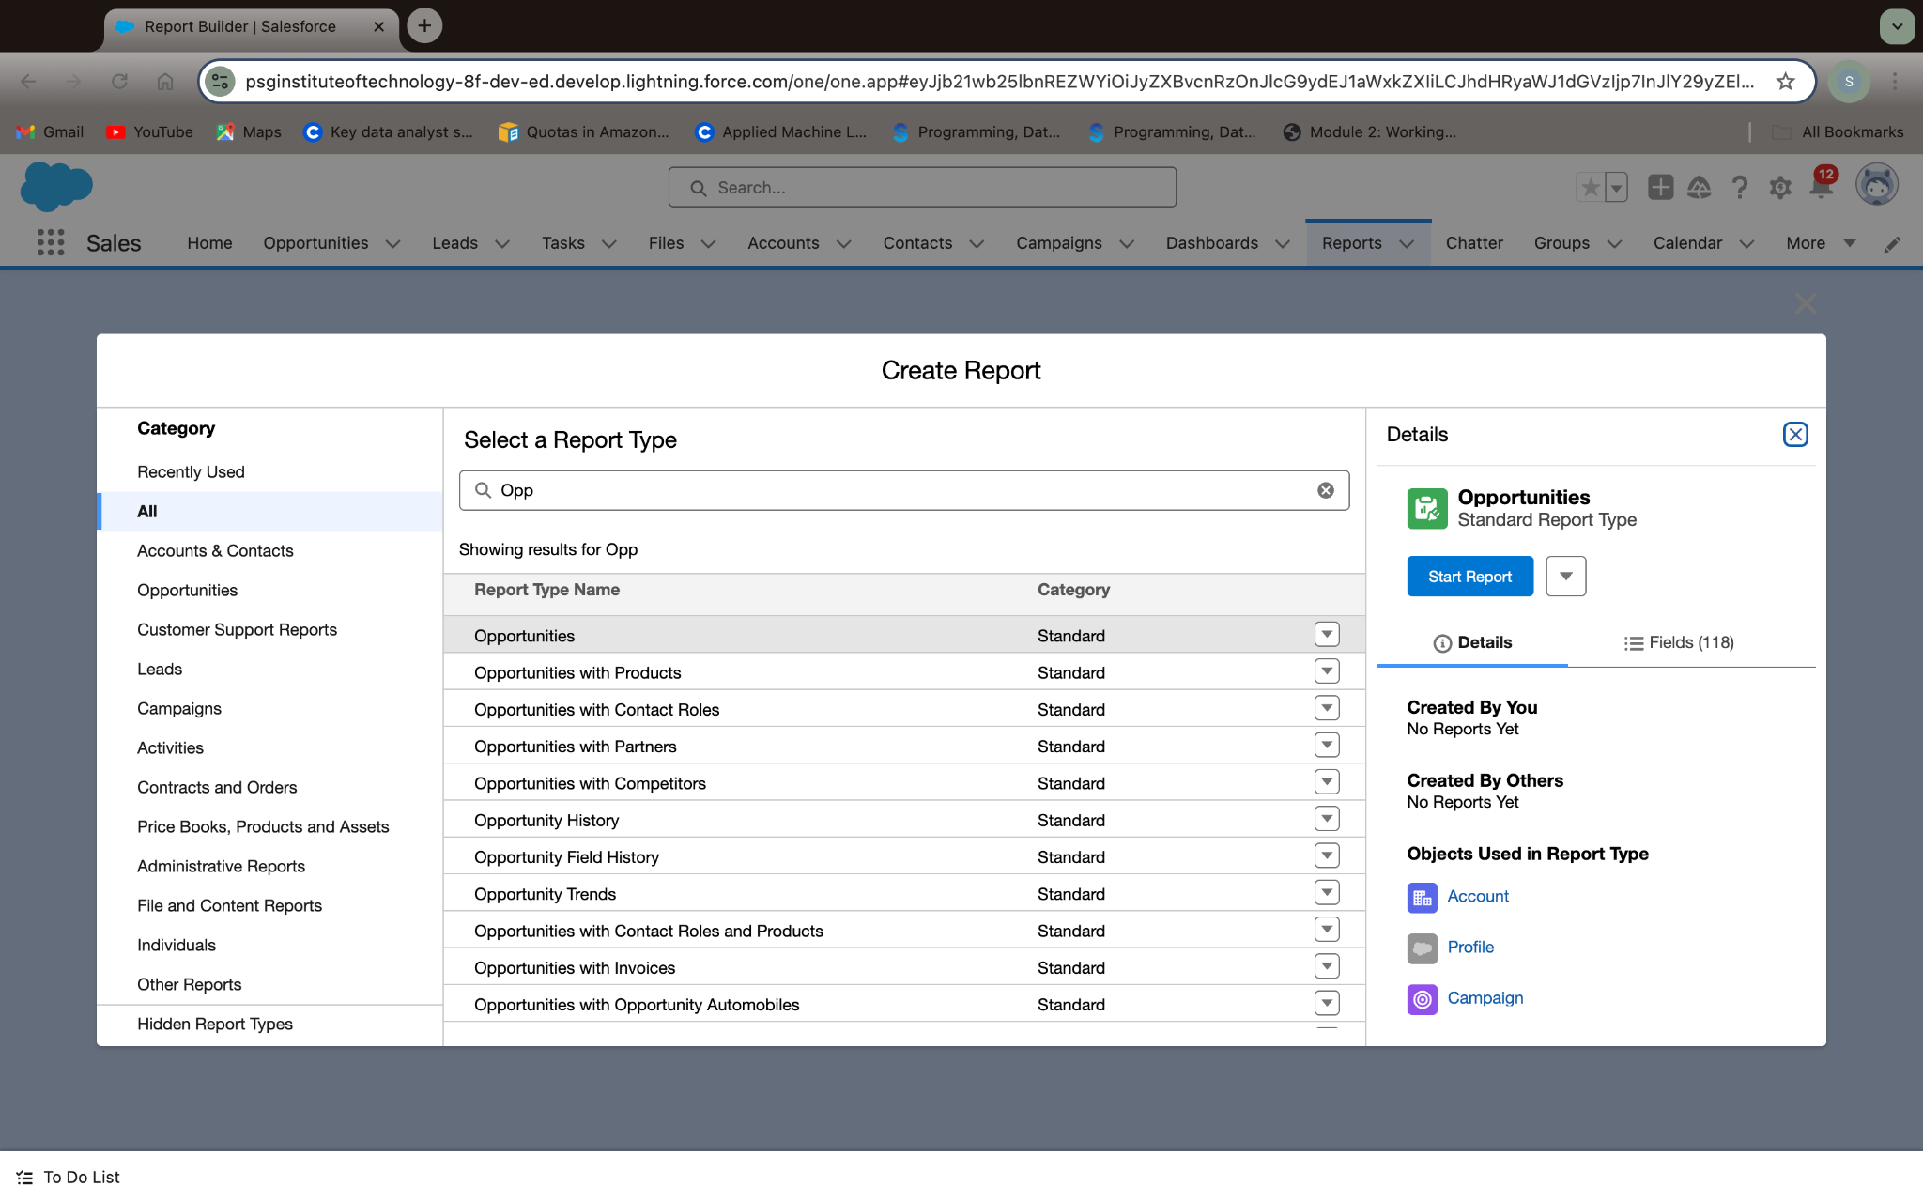

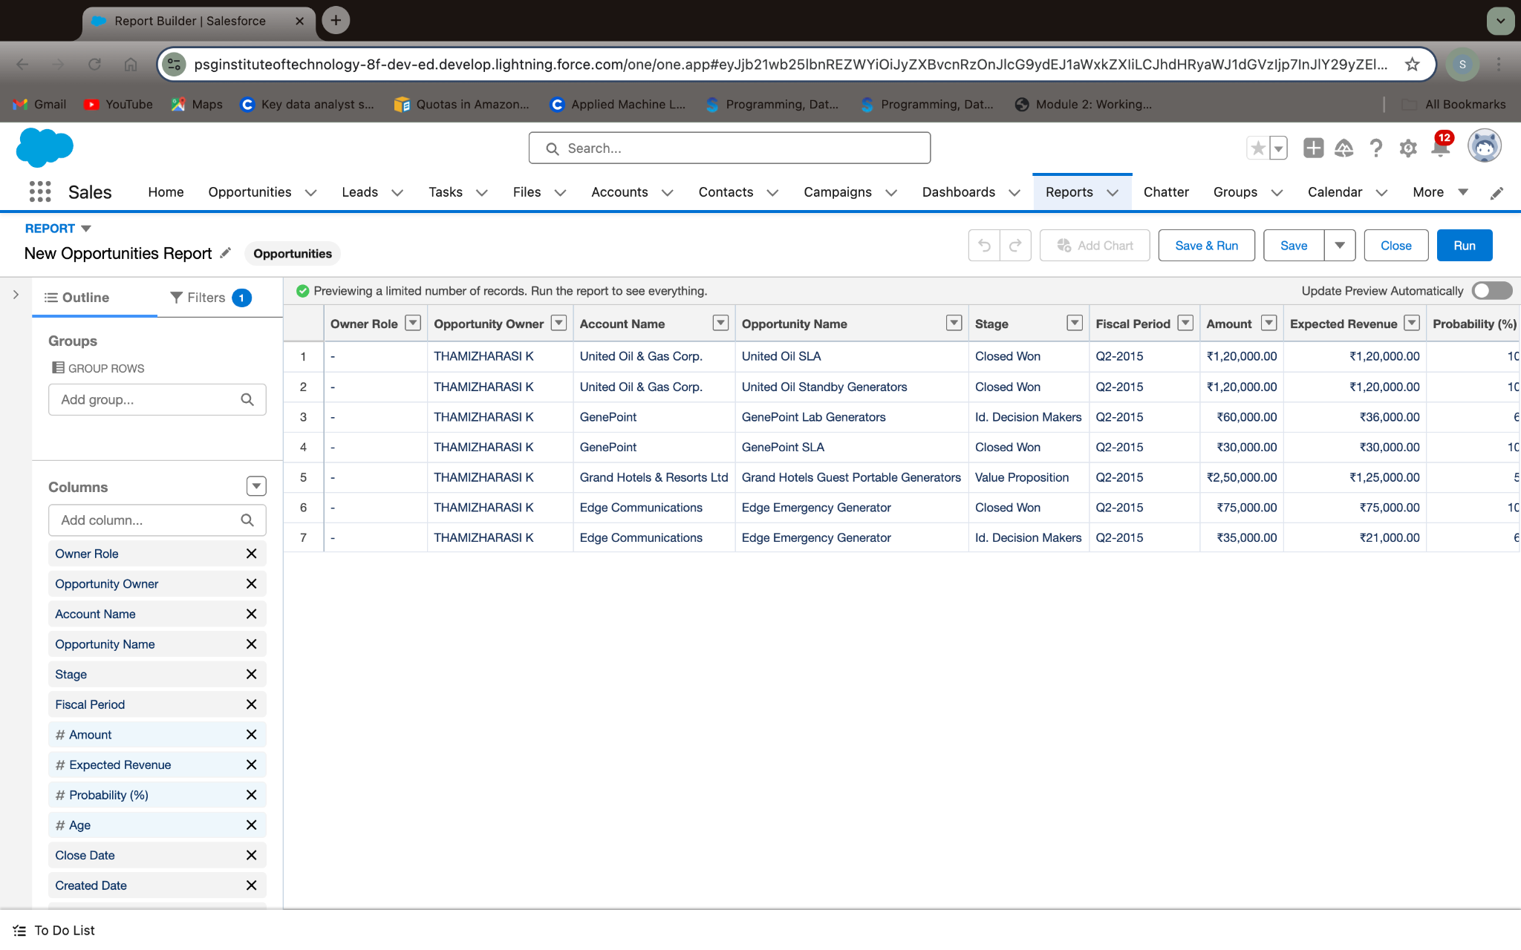

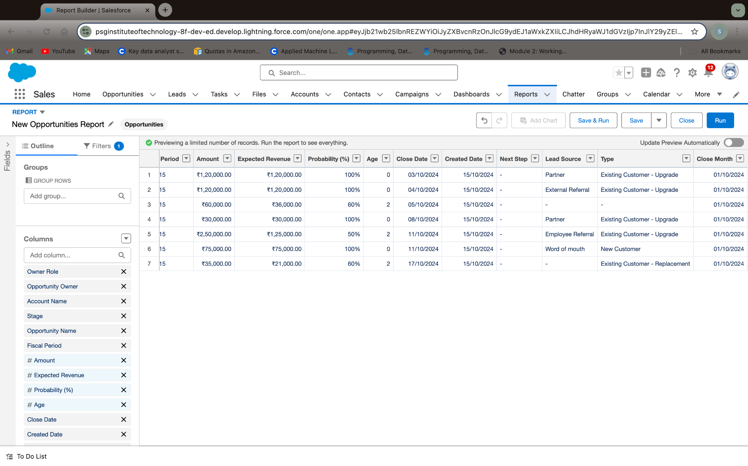

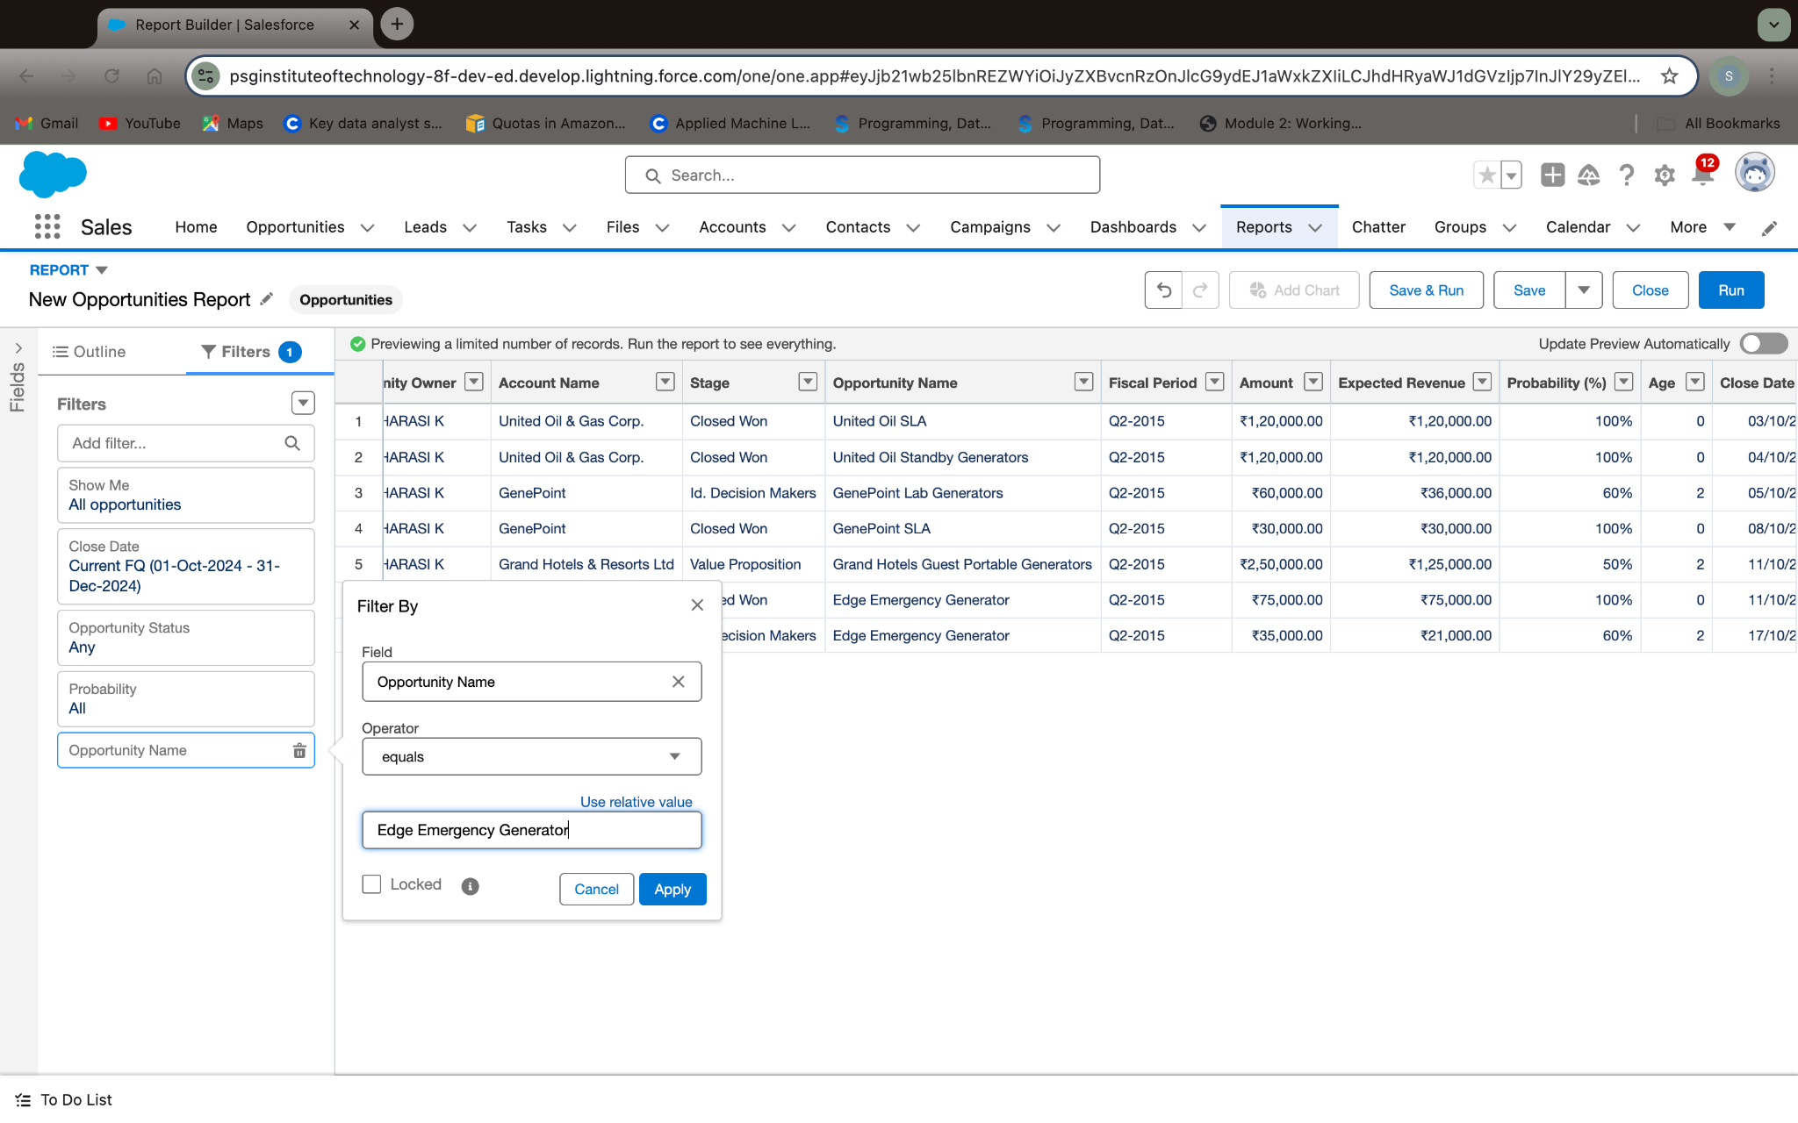

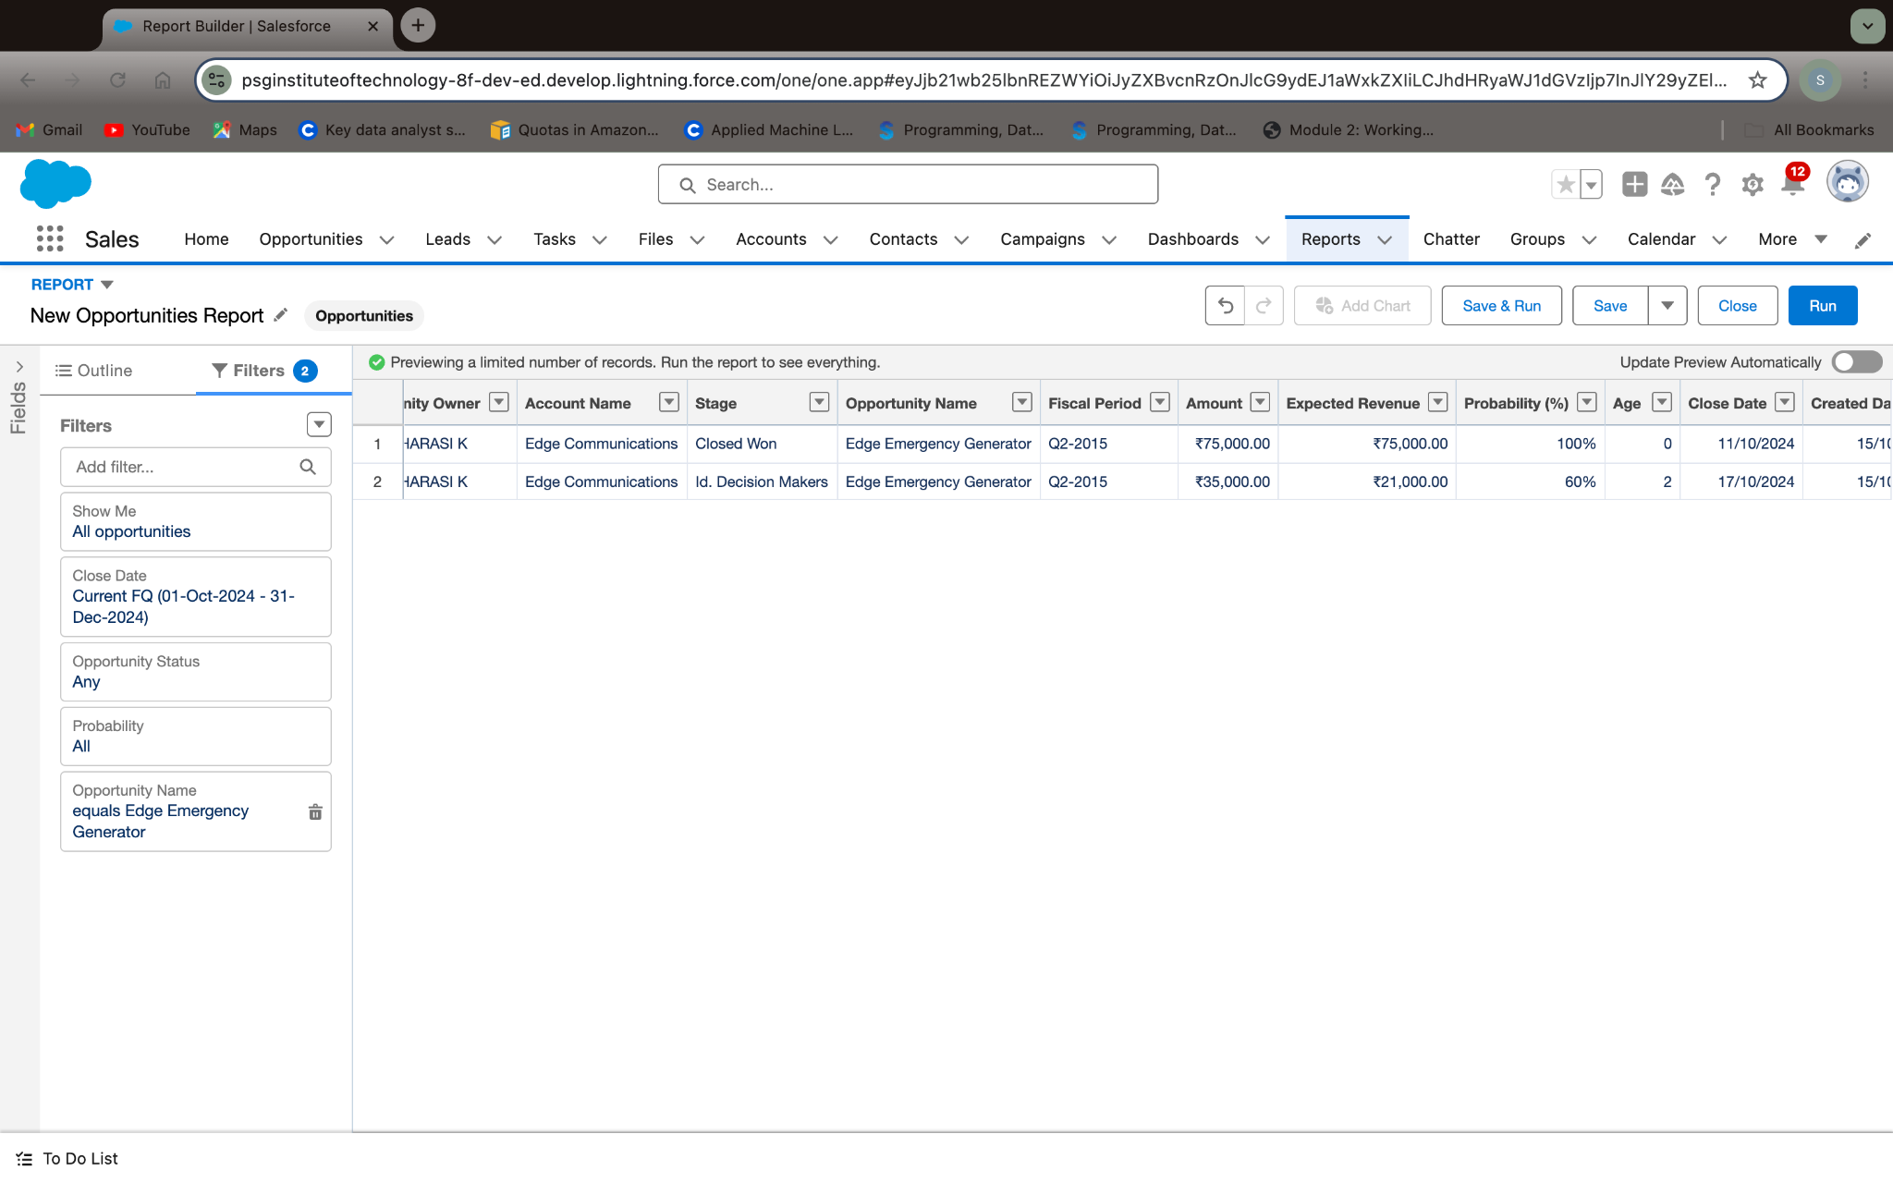

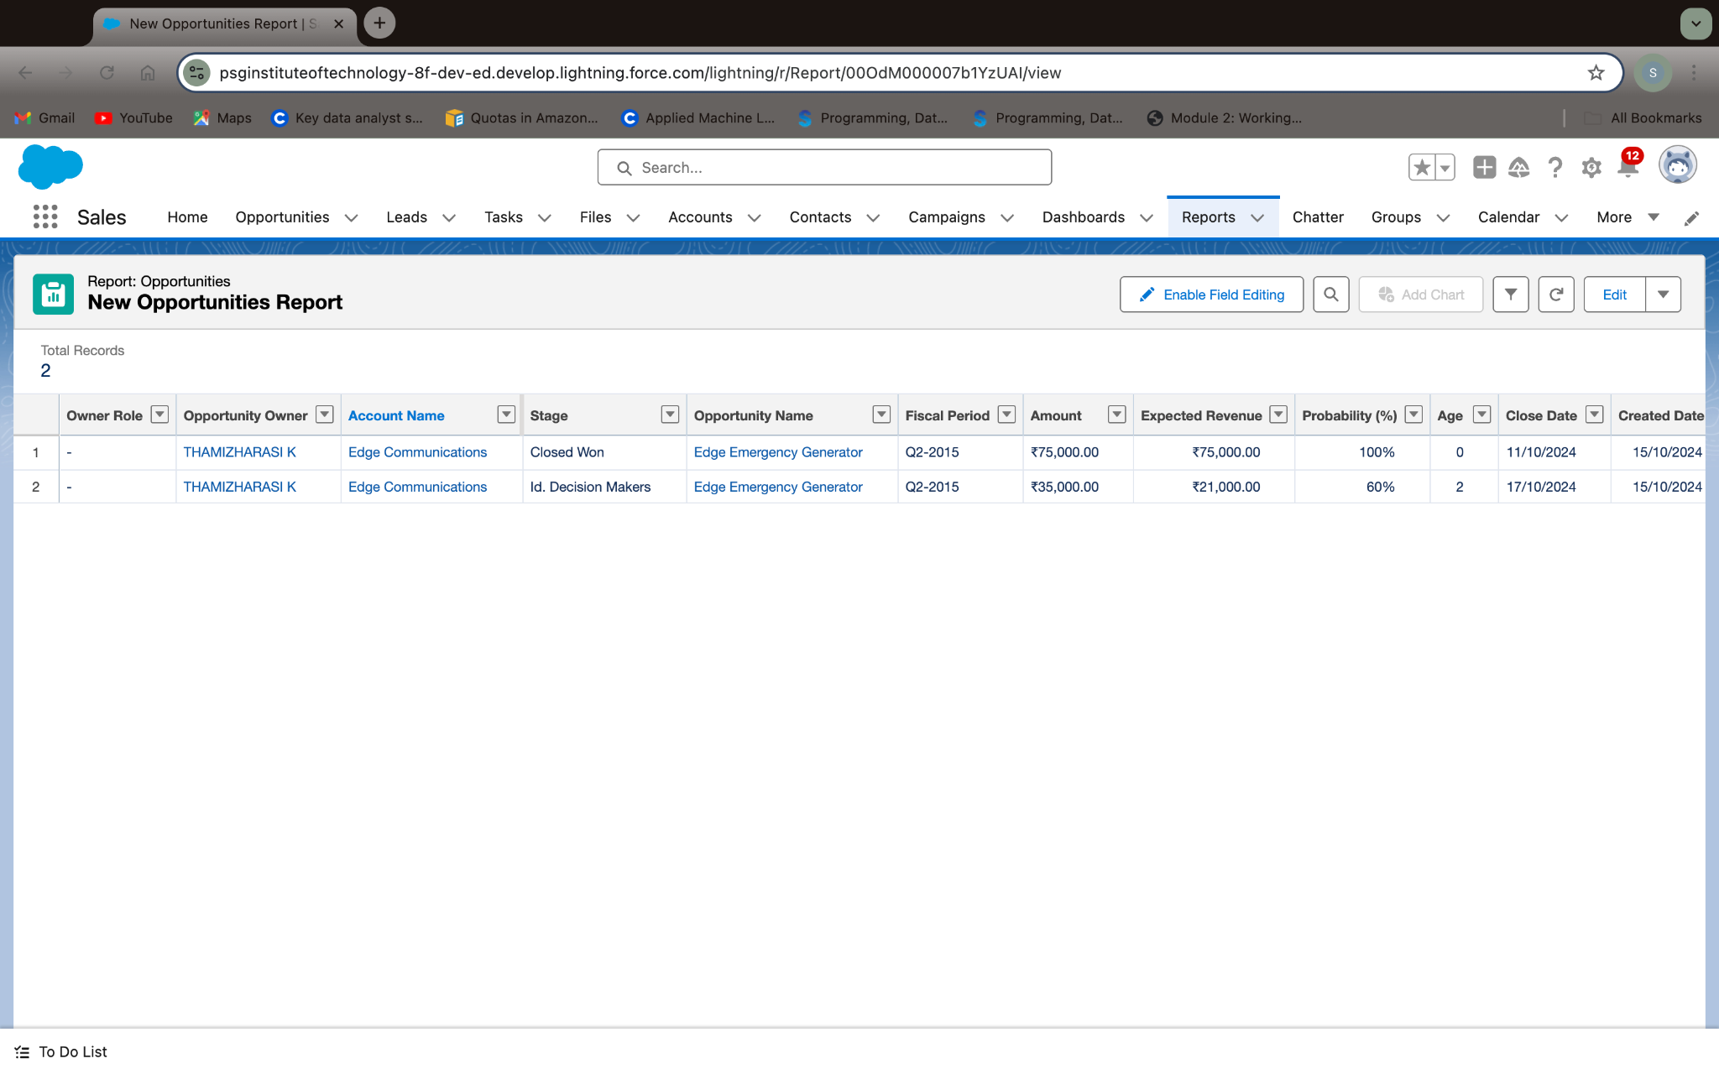

### **Create Report on Automobile Information**

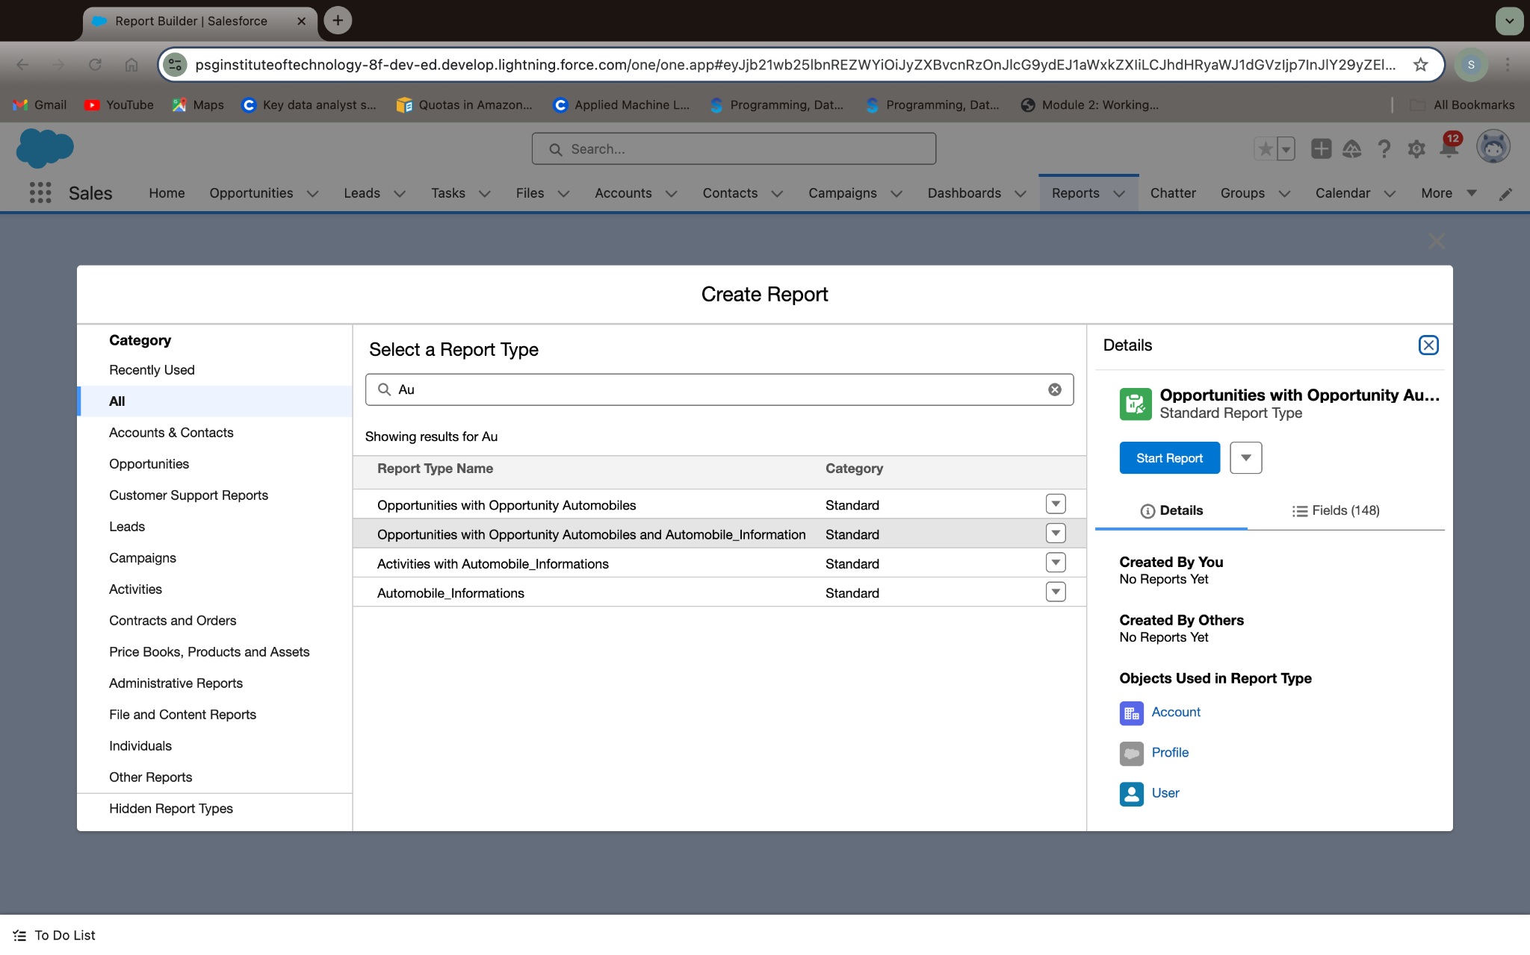

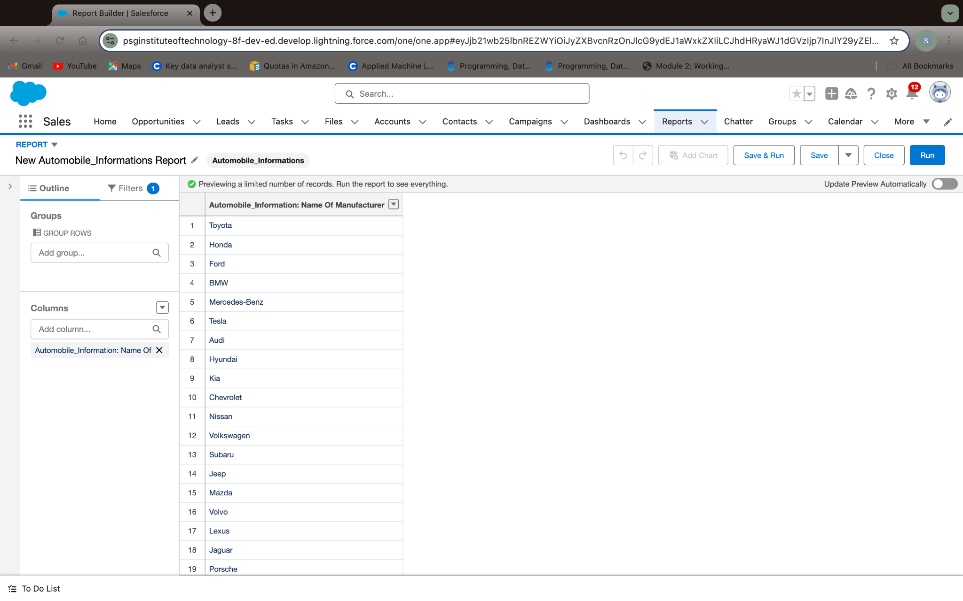

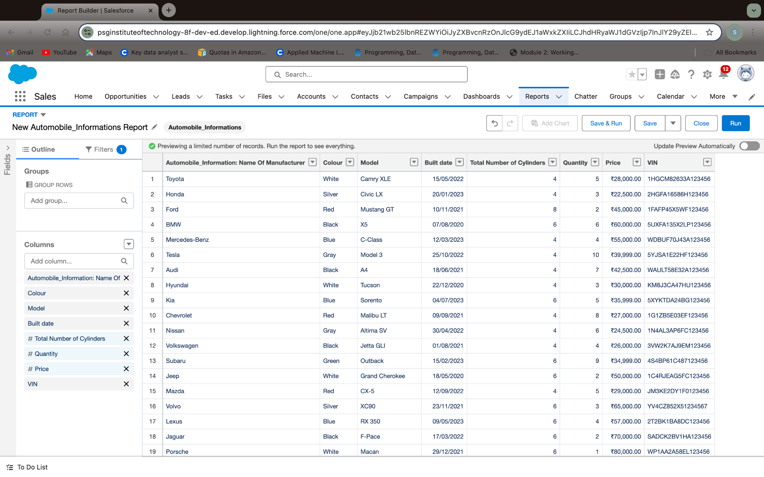

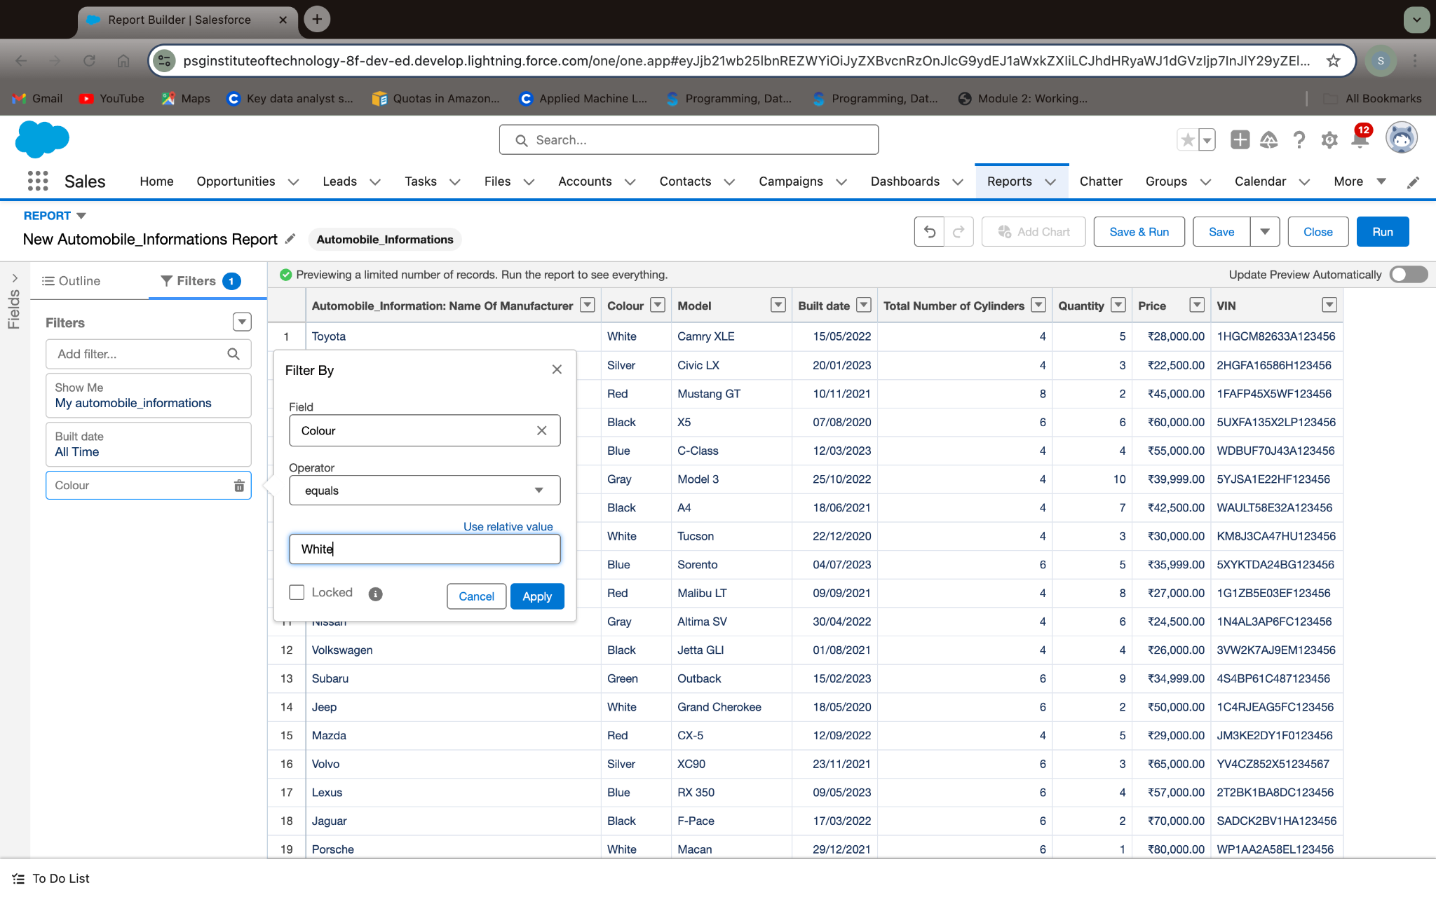

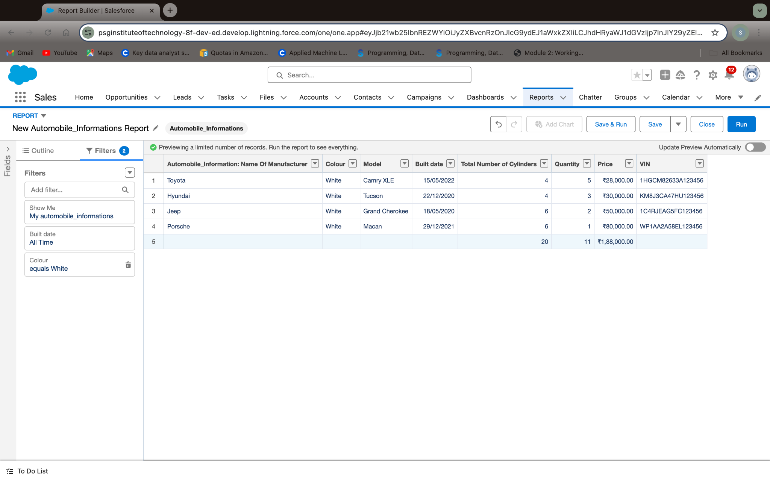

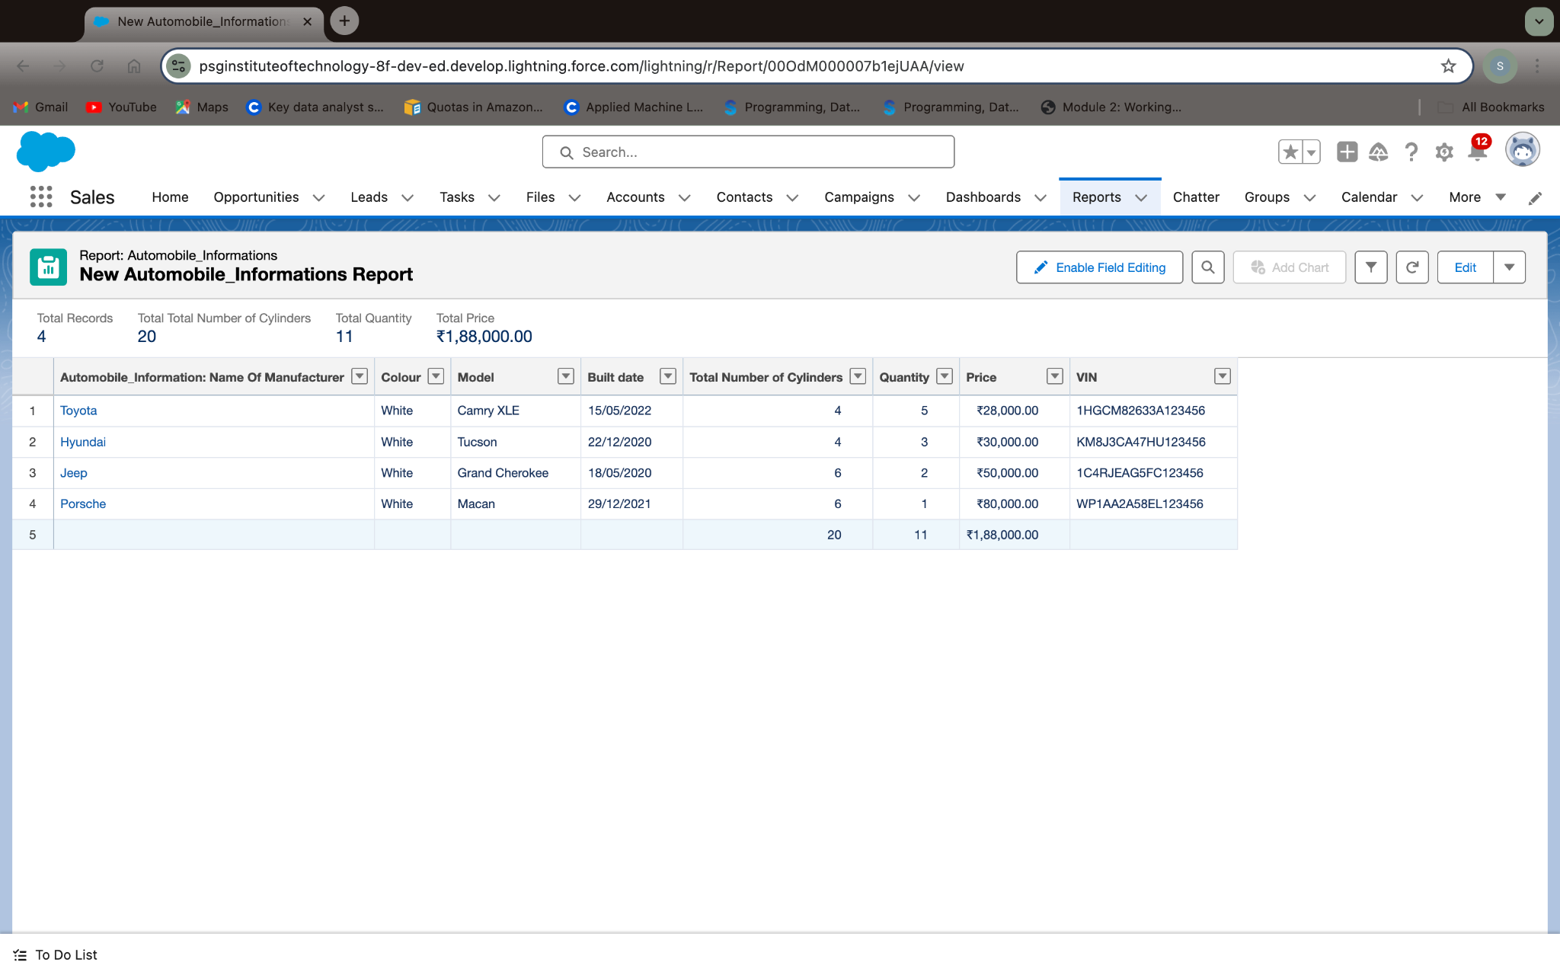

**Remark (by mentor):**

**Task no: 11**

**Task Name:Dashboard**

**Done by:Srinithi A  
Screenshots:**

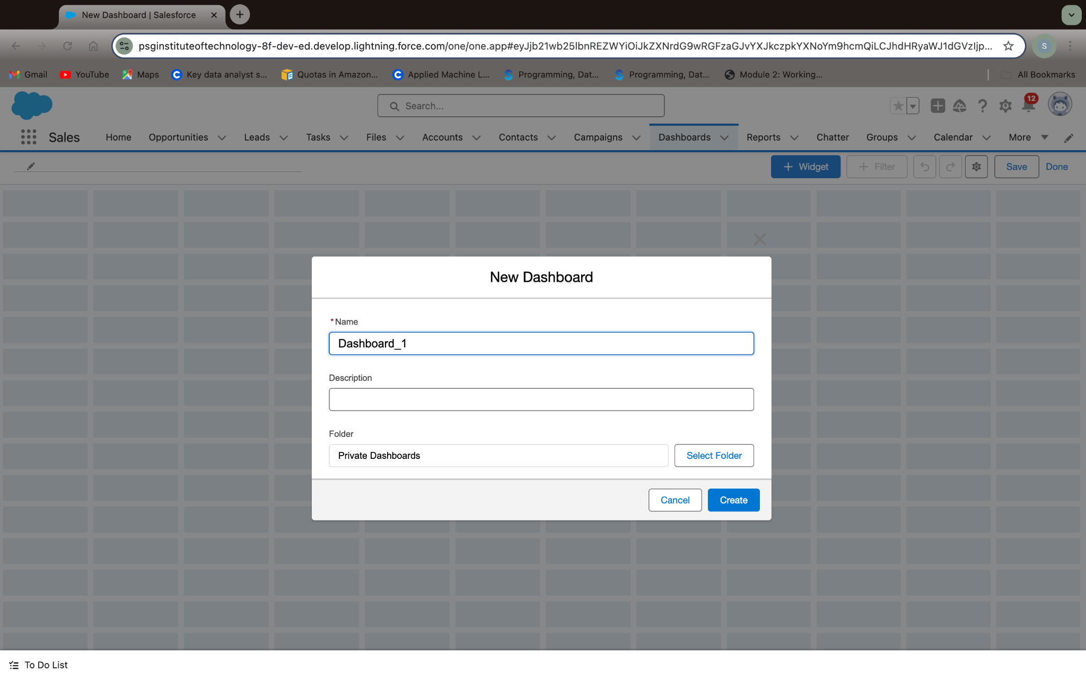

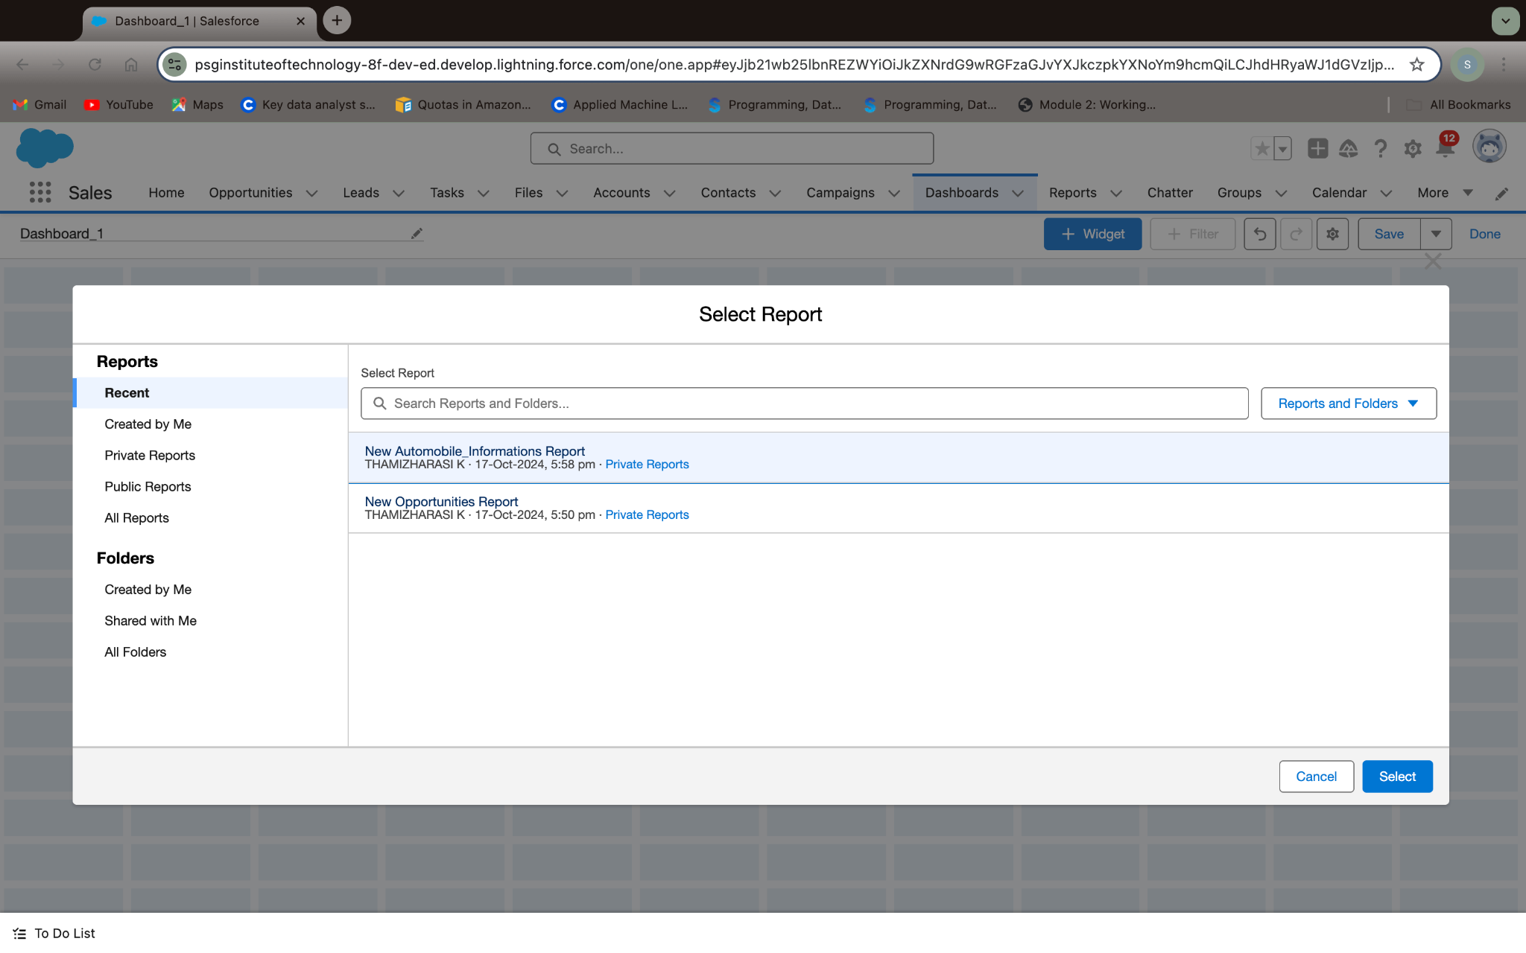

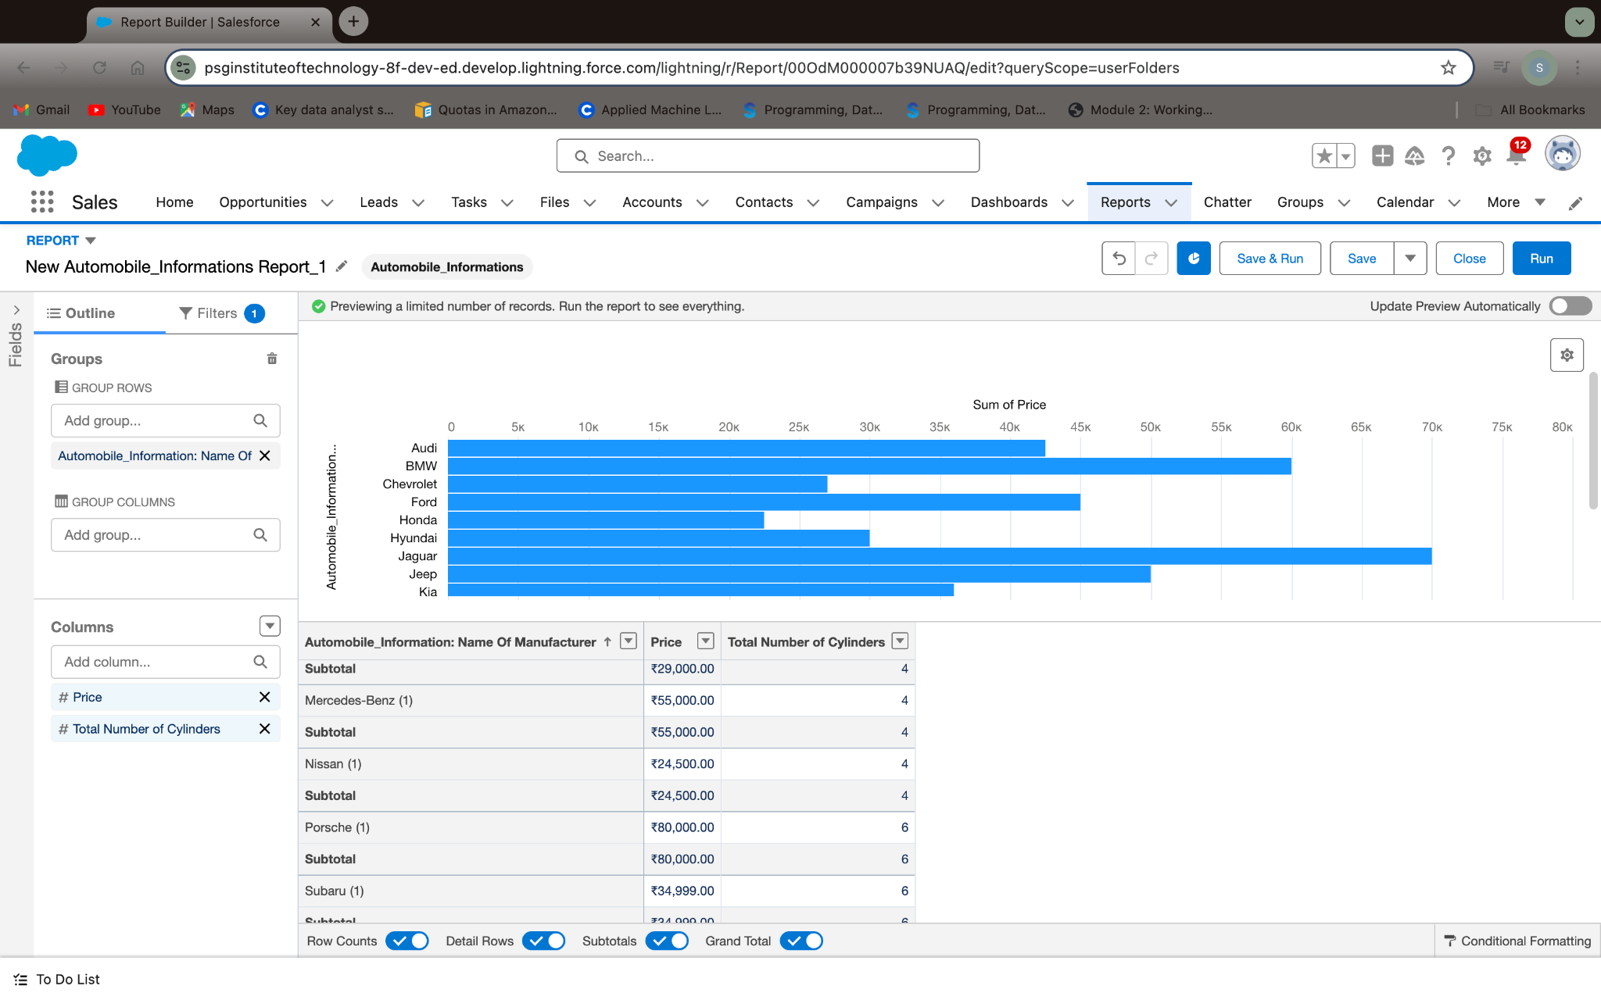

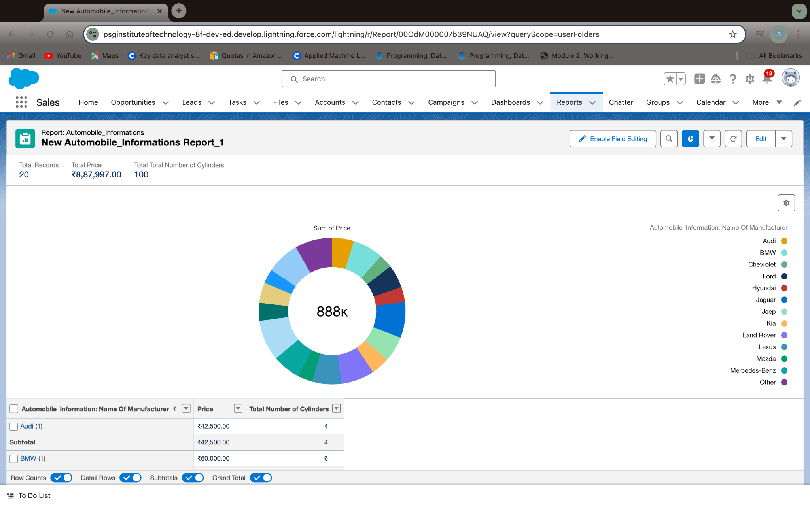

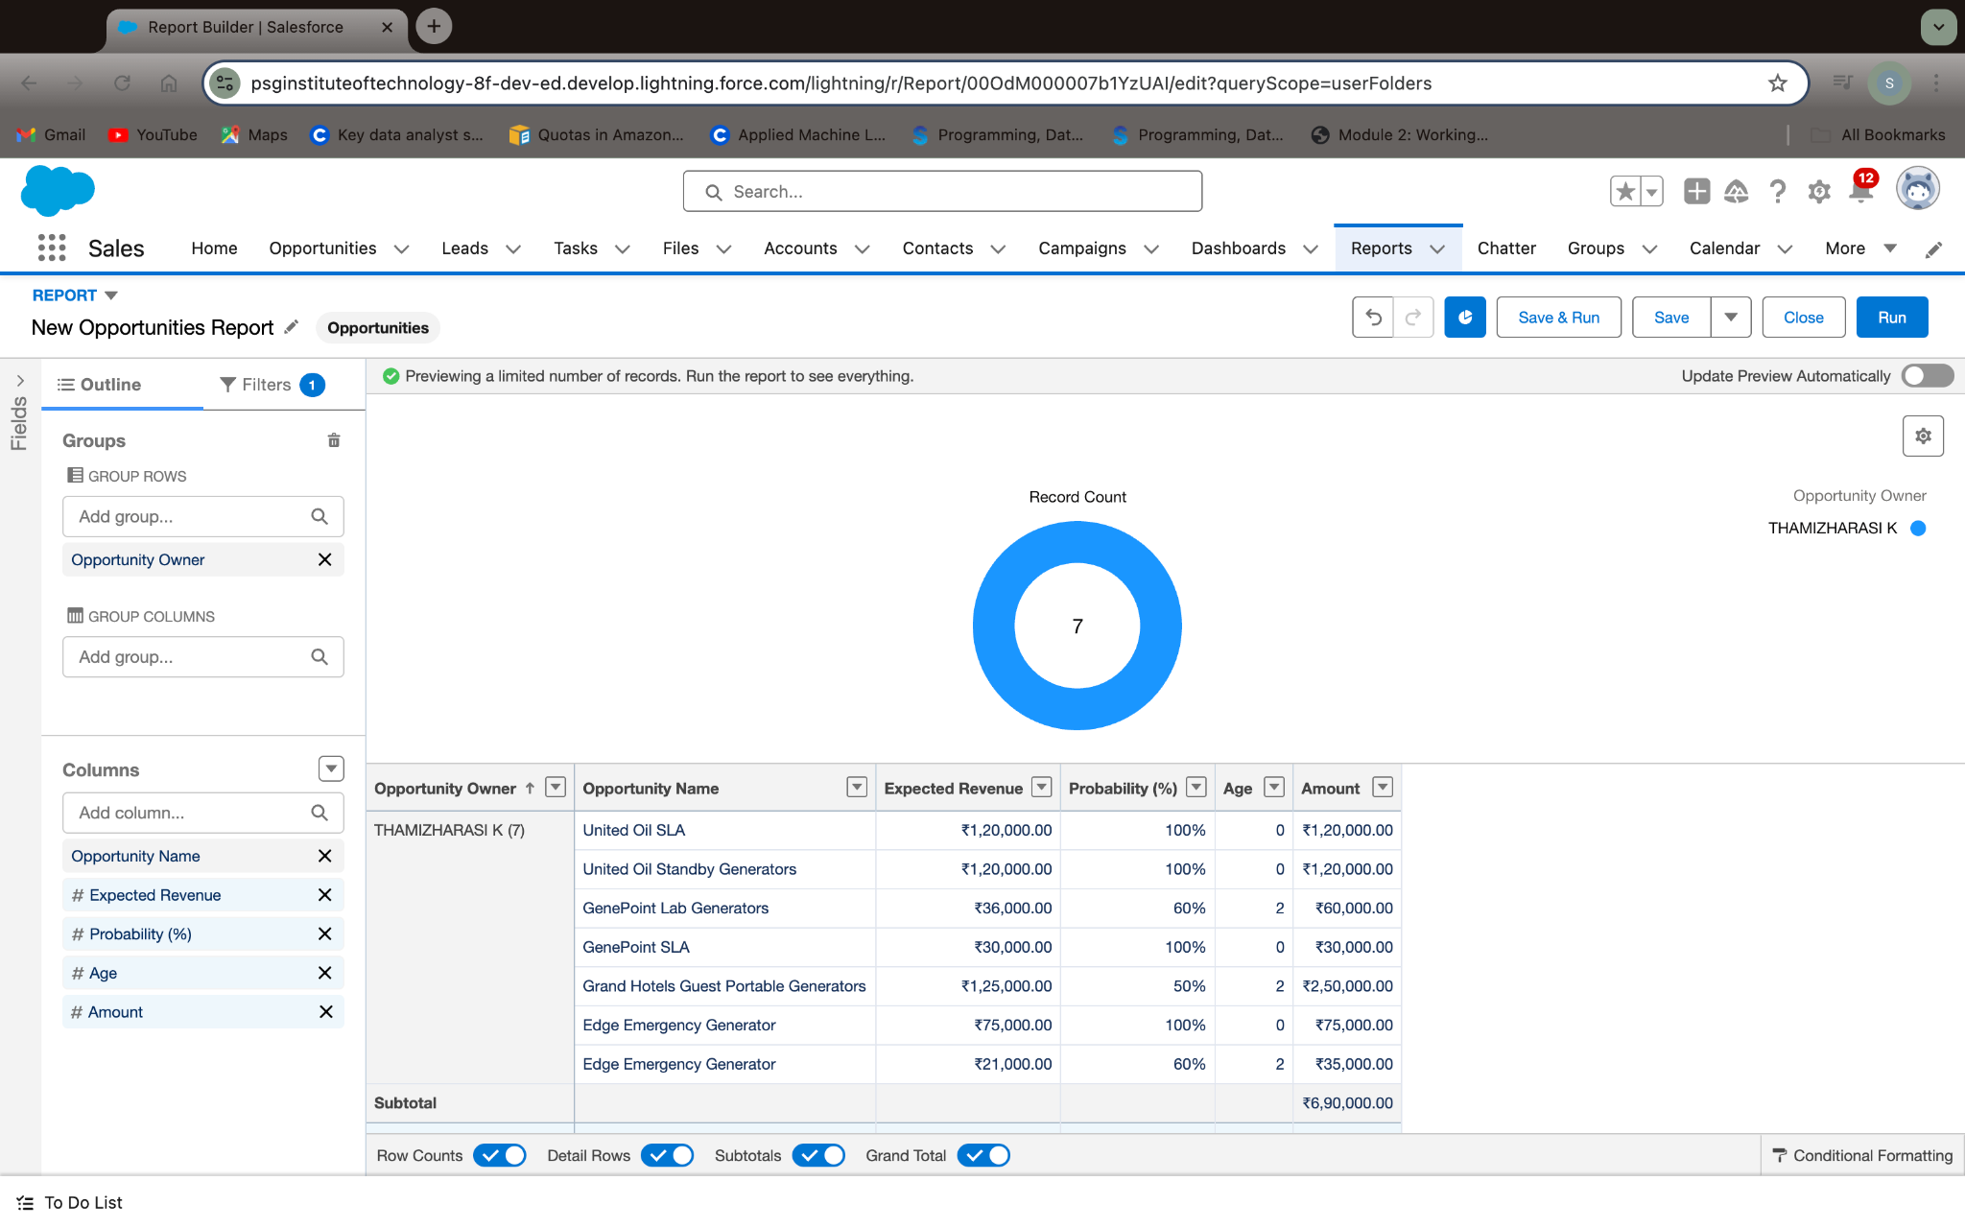

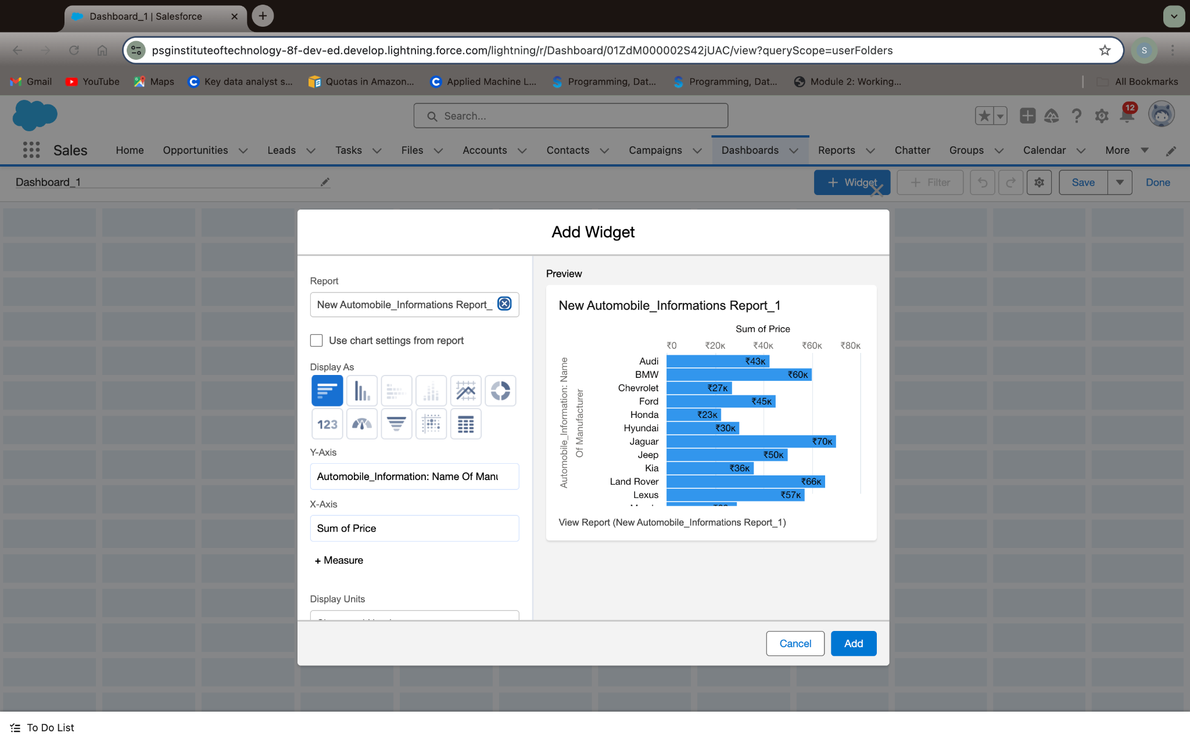

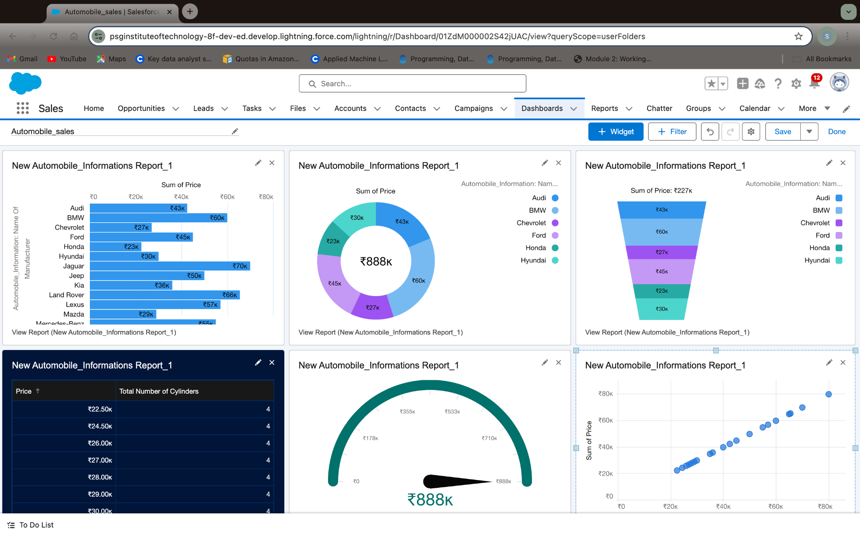

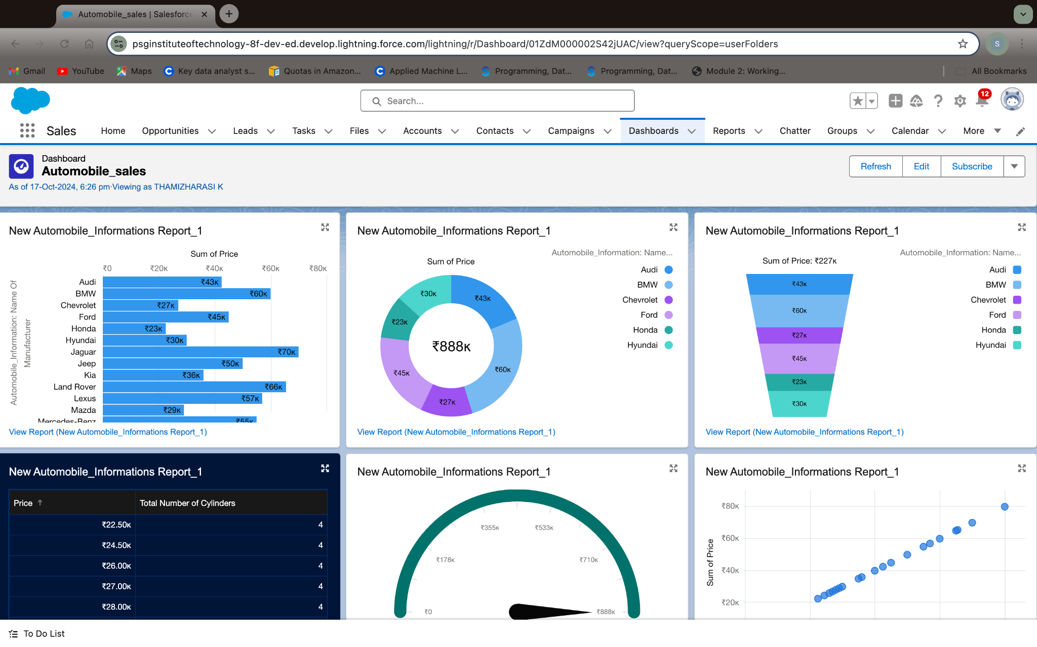

**Remark (by mentor):**